Introduction

This week we are invited to take a closer look at the will that the Father has with Jesus and was expressed by Jesus at the Last Supper, teaching his apostles to do the same for the salvation of many.

The Father gave his only begotten Son to save his people, and Jesus did by giving his life at the cross for the forgiveness of sins. Before he died, Christ instituted the Holy Eucharist at the Last Supper. He took bread, blessed and broke it, and gave it to his apostles, saying, “Take and eat; this is My Body” (Mt 26:26). Finally, he gave his apostles the commission: “Do this in memory of me” (1 Cor 11:24). It is the action by which Jesus gives himself to us, and we in turn are called to act and continue as he did. This command does not only ask us to remember Jesus and what he did but to put into practice his teachings.
The Eucharist is the itinerary which each apostle has to pass through if he wants to become like his master.
Monday
“Eucharist: Forge where the genuine personality of the apostle is formed”

VD Constitutions 74
The Eucharist is the forge where, in an intimate transforming dialogue, the genuine personality of the apostle missionary is forged. In the Eucharist, the missionary's internal character is configured, making him/her its witness throughout the whole world. Before the Tabernacle we translate and transform into life the truths of faith that we are to propagate in a vital way until all “have life and have it to the full.”

We can understand the formative itinerary that the Father did in Jesus from the Eucharist, where, at the same time, Jesus transforms and configures the internal character of the Apostle. The Eucharist is the greatest gift Jesus left us, and celebrating it gives us our identity as well as our life.

The Eucharist is the sum and summary of our faith: “Our way of thinking is attuned to the Eucharist, and the Eucharist in turn confirms our way of thinking (CCC 1327).

What are we willing to sacrifice in order to bring out our real identity and have life to the full?

Tuesday
“Jesus took a piece of bread
and blessed it”
Matthew 26:26
While they were eating, Jesus took bread, said the blessing, broke it, and giving it to his disciples said, “Take and eat; this is my body.”
Jeremiah 18:1-4
The Lord said to me, “Go down to the potter's house, where I will give you my message.” So I went there and saw the potter working at his wheel. Whenever a piece of pottery turned out imperfect, he would take the clay and make it into something else.
Jesus, being our master, takes our lives into his hands and forms us. He assumes the total responsibility of our lives, but he asked from us to be docile in order to form us (mind, heart, and will) and bless it through his word.
Do we allow Jesus to transform and configure us totally?

Wednesday

“Broke the bread
and gave it to them”
Matthew 16:23
Jesus turned around and said to Peter, “Get away from me, Satan! You are an obstacle in my way, because these thoughts of yours don't come from God, but from human nature.”
Luke 22:33
Peter answered, “Lord, I am ready to go to prison with you and to die with you!”
This is the stage of purification. Jesus purifies our intentions and paradigms in order to live the values of the kingdom. But he always has hope in us, looking at our lives with so much potential, fully trusting that we can be light for others.
Do we welcome God's perspectives about us? Are we ready to embrace God's will for our lives so that others may have life?
Thursday
“This is my body”
Galatians 2:20
So that it is no longer I who live, but it is Christ who lives in me. This life that I live now, I live by faith in the Son of God, who loved me and gave his life for me.

Isaiah 55:9
As high as the heavens are above the earth, so high are my ways and thoughts above yours.
The transformation and formation of the apostles doesn’t finish until Jesus becomes visible in them. The apostle needs to love and to forgive like his master.
Make Jesus visible in our lives. Make him alive for others.
In what way can we make Jesus visible in our lives?
Friday
“Eat all of it”
Jeremiah 1:6-7
I answered, “Sovereign Lord, I don't know how to speak; I am too young.” But the Lord said to me, “Do not say that you are too young, but go to the people I send you to, and tell them everything I command you to say.

John 21:18
I am telling you the truth: when you were young, you used to get ready and go anywhere you wanted to; but when you are old, you will stretch out your hands and someone else will tie you up and take you where you don't want to go.”
Jesus forms in the apostle the awareness that he is sent not to be served but to serve; that he needs to go through the experience to be consumed to be able to evangelize and to convert others. The experience of the apostle to be eaten happens when one doesn't want the mission that God is entrusting to him, like for instance to preach in certain moments that he feels poor and to go where he doesn’t want to go. But do we trust God enough to help us understand the true meaning of service?

Saturday
“Do this in memory of me”

1 Corinthians 11:23-25
For I received from the Lord the teaching that I passed on to you: that the Lord Jesus, on the night he was betrayed, took a piece of bread, gave thanks to God, broke it, and said, “This is my body, which is for you. Do this in memory of me.” In the same way, after the supper he took the cup and said, “This cup is God's new covenant, sealed with my blood. Whenever you drink it, do so in memory of me.”
Jesus shows us with his life that the happiness is not to be a master but to form masters and shepherds who will continue the desire of the Father. “In Memory” is not only to remember but to make real. So as apostles we should do an option to form others apostles as our master did.

Sunday
22nd Sunday in Ordinary Time
1st Reading: Jer 20:7-9
Psalm: Ps 63
2nd Reading: Rom 12:1-2
Gospel: Matthew 16:21-27

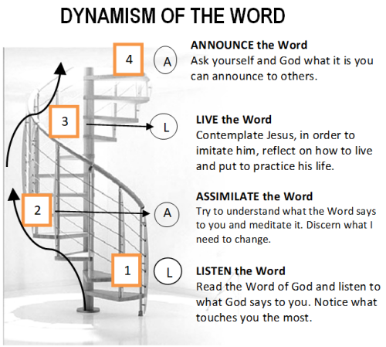

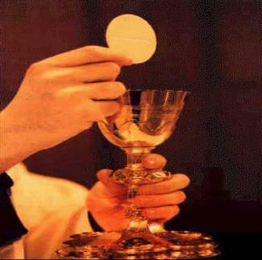
GUIDELINES FOR PRAYER

Aug 28–Sept 3, 2017
“Do this
in memory of me”
(1 Cor 11:24)
General Theme:
“Jesus sat down and taught them” John 8:2

General Objective:
To deepen on how to form disciples- apostles of Christ and to give content in the formation of apostles

Specific Objective:
To reflect and to assimilate the itinerary that the Father has made with Jesus, expressing it with his life in the Last Supper in order to do the same itinerary in the apostle-formator

