INTRODUCTION
Last week we were invited to contemplate Jesus as a different Master/Formator. This week we are invited to contemplate on how Jesus formed his disciples' long time ago through His pedagogy - the very same way he is forming us today. When Jesus forms his apostles, he forms their whole being, more so their conscience. “Conscience must be formed and moral judgment enlightened. A well-formed conscience is upright and truthful. It formulates its judgments according to reason, in conformity with the true good willed by the wisdom of the Creator. The education of conscience is indispensable for human beings who are subjected to negative influences and tempted by sin to prefer their own judgment and to reject authoritative teachings” (CCC II-1783). Jesus had taught us many things. He has even given us authority to continue his mission and to form apostles who are faithful and who in turn will to do the same. Jesus had once said “Go and make disciples”; these are the very words that motivate us to continue our journey in forming apostles. In this moment we are encouraged to form others as we have been formed by Christ through the people who had gone before us, those who had been faithful to the calling of Christ. Let us now deepen on how Jesus had formed us as apostles. Let us be convinced that through forming others, we can make a difference in the world like what our founder had done. Let us be reminded always that the Lord Jesus desires for all of us his people to be saved, be redeemed, and be happy for all times. Learning from Christ is the best way to form others. It has been said that Jesus had come down from heaven to lead us how to live our life, a life to its fullness by learning how to listen to the will of the Father for each one of us.
MONDAY
Jesus taught his disciples with love
Mk 6:34 When Jesus got out of the boat, he saw this large crowd, and his heart was filled with pity for them, because they were like sheep without a shepherd. So he began to teach them many things.
Mk 12:44 As Jesus sat near the Temple treasury, he watched the people as they dropped in a lot money; then a poor widow came along and dropped in two little copper coins, worth about a penny. He called his disciples together and said to them. I tell you that this poor widow put more in the offering box than all the others. For others put in what they had to spare of their riches, but she, poor as she is, put in all she had-she gave all she had to live on.

Jesus teaches many things to his disciples with compassion and mercy. He contemplates the nature, the events, and the happenings around Him, and through them He teaches his disciples. As He teaches his disciples, He opens their hearts to the reality of life and to what matters most to God.
To form apostle/disciples is to give to them what they need without restrictions but compassion and mercy.
Are we willing to be more compassionate like Jesus in giving what we have to others in need?

TUESDAY
Jesus taught his disciples to enter into their inner self
Mt 16:15 What about you? He asked them. Who do you say I am?

Jn 1:38 Jesus turned, saw them following him and asked, “What are you looking for?” They answered. “Where do you live Rabbi?” (This word means “Teacher”)

Lk 22:27 Who is greater, the one who sits down to eat or the one who serves? The one who sits down, of course, but I am among you as one who serves.

Jesus wants to connect and motivate his disciples to be more interactive and help them think by asking them questions and helping them to make an evaluation from within. He questioned his disciples in order that they learn to enter into their inner self and find answers.
To form apostle is to provoke in themselves what are they looking for and what makes them happy.
Do we continue to stay with Jesus and discover the answers to our questions?

WEDNESDAY
Jesus taught his disciples the truth with simplicity
Jn. 10: 9, 11 I am the gate. Those who come in by me will be saved; they will come in and go out and find pasture. I am the good shepherd, who is willing to die for the sheep.

Jn 13:34 And now I give you a new commandment: love one another. As I have loved you, so you must love one another.

Mk 9:23 “Yes”, said Jesus “if you yourself can! Everything is possible for the person who has faith.
Jesus simplifies his teaching using short phrases and common symbols tangible and visible to the reality of the people He is teaching. With this pedagogy of teaching, people remember the teaching of Jesus the moment they saw the symbol Jesus is using. They may not remember everything but the content of what Jesus was saying is already instilled in their mind and clearly, the teaching gradually becomes alive in the life of each disciple and apostle.
What symbol or short phrase you remember from Jesus? How does it help you to this moment of your following?

THURSDAY
Jesus pointed out in his teachings what is essential
Mt 13:10-14, 16 – Then the disciples came to Jesus and asked him, “Why do you use parables when you talk to the people?” Jesus answered, “The knowledge about the secrets of the Kingdom of heaven has been given to you but not to them. For the person who has something will be given more so that he will have more than enough; but the person who has nothing will have taken away from him even the little he has. The reason I use parables in talking to them is that they look, but do not hear or understand. As for you how fortunate you are. Your eyes see and your ears hear. I assure you that many prophets and many of God’s people wanted very much to see what you see, but they could not and to hear what you hear but they did not.

Mt 13:34-35 Jesus uses parables to tell all these things to the crowds; he would not say a thing to them without using a parable. He did this to make come true what the prophet had said, “I will use parables when I speak to them; I will tell them things unknown since the creation of the world”.

Jesus teaches the same thing but says it in different ways in order to mark in the disciples the essential aspects of his teaching. In parables, only those who have faith and knowledge about Jesus understand its meaning.
How happy are those who continue to follow Jesus, for everything has been and will be revealed by Christ to them.
What are the things that Jesus is revealing to you at this moment?

FRIDAY
Jesus taught with His life
Jn. 10:4 The good shepherd goes ahead of them.

Jn 13: 34-35 And now I give you a new commandment: love one another. As I have loved you, so you must love one another. If you have love for one another, then everyone will know that you are my disciples.

Phil. 2:7 Instead of this, of his own free will he gave up all he had and took the nature of a servant.

Lk 23:34 Jesus said, Forgive them Father! They don't know what they are doing.

Jesus walked and lived all what he preached. He didn’t give a congress about forgiveness: He forgave. He forgave the crowds that mocked him and shouted,” crucify him”. He didn’t give a course on poverty; he was poor. He did not own a house to stay for the night to rest, He didn’t have the luxury of buying what He wanted, He chose to serve than to be served. He didn’t use a Greek etymology to explain what love is. He loved. He loved from birth to death.
How are we this time? Is our life a reflection of Jesus and His teaching?

SATURDAY
Jesus fulfilled the Good News
Mt. 5: 17-20 I have not come to do away the prophets and the law but to make their teaching comes true.

Lk.4:1-13 Jesus returned from the Jordan full of the Holy Spirit and was led by the Spirit into the desert, where he was tempted by the Devil for forty days. In all that time he ate nothing, so that he was hungry when it was over. The devil said to him if you are god's son, order this stone to turn into bread. But Jesus answered the scripture says human beings cannot live on bread alone. Then the devil took him up and showed him in a second all the kingdoms of the world. I will give you all this power and all this wealth, the devil told him. It has all been handed over to me and I can give it to anyone I choose. All this will be yours, then, if you worship me. Jesus answered “The scripture says Worship the Lord you God and serve only him. Then the devil took him to Jerusalem and set him on the highest point of the temple and said to him if you are God's Son, through yourself down from here. For the scripture says, God will order his angels to take good care of you it also says they will hold up with their hands so that not even your feet will be hurt on the stones. But Jesus answered, the scripture says do not put the Lord your God to the test. When the devil finished tempting Jesus in every way, he left him for a while.

He deepened on the essence of the prophets and the law and made them accessible to everyone, and at the same time, in important moments he approached the authority of the law and prophets in order to respond.
What are the invitations of Christ that we have fulfilled and have done? How does it affect us when we accomplished what he asked of us?

SUNDAY
20th Sunday in Ordinary Time
1st Reading: Is 56:1, 6-7
Psalm: Ps 67:2-3, 5, 6, 8
2nd Reading: Rom 11:13-15, 29-32
Gospel: Mt 15:21-28

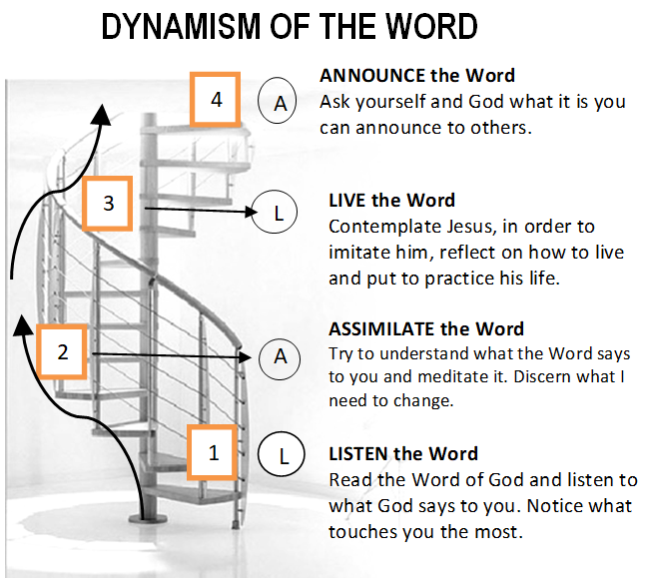

GUIDELINES FOR PRAYER
“LEARN FROM ME”
August 14-20, 2017
General Theme:
“Jesus sat down and taught them" Jn 8:2

General Objective:
To deepen how to form Disciples/Apostles of Christ and to give content in the formation of Apostles.

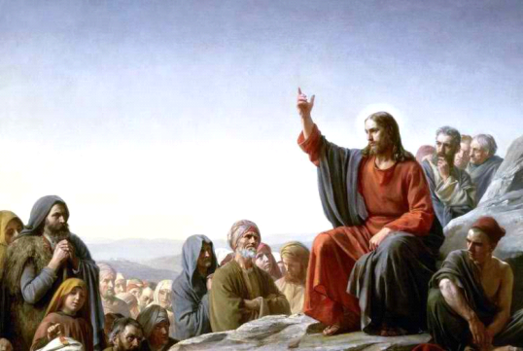
Objective of the week:
To learn from Jesus His pedagogy to form apostles.

Page 1 of 3
Guidelines Sheet for Prayer

