Introduction
“I have made you known to those you gave me out of the world. They belonged to you, and you gave them to me. They have obeyed your word, and now they know that everything you gave me comes from you. I gave them the message that you gave me, and they received it, they know that it is true that I came from you, and they believe that you sent me.” (Jn.17:6-8)
“I sent them into the world, just as you sent me into the world. And for their sake I dedicate myself to you in order that they too may be truly dedicated to you.” (Jn.17:18-19)
Jesus, in every prayer and encounter with Him, is showing His desire for us to learn so that we can in turn teach others to do the same. Let us continue contemplating Him, His words and actions.
We are invited to deepen our personal relationship with God to prepare for the challenges ahead of us. Even the disciples who went with Jesus had also experienced temptations the same way we are experiencing now. Let us fix our eyes on Jesus in the gospel in order to continue with the mission just like what Fr. Jaime Bonet has shown us.
We are all blessed by the life of our founder, Fr. Jaime Bonet. With him, we are able to know how to pray and to listen to the word of God. His spiritual encounters and discoveries with the Lord overwhelmed him to follow Christ faithfully. His decision to follow never wavered from the time he engaged into the mission until his death; he became a formator to all those who wanted to encounter Christ. His sincere devotion to the Gospel gave blessing to all of us. His teachings sparked the fire of love in our hearts, his complete submission to the Lord showed us the assurance of joy and salvation ahead of us. His yes to God, has enabled us to receive his spiritual legacy. Let us keep this legacy ever active and productive for his aim is to sow Christ in the hearts of the many.
So let us emulate Jaime in following Christ in committing ourselves into prayer and investing our life for him and for the Kingdom of God. Our willingness to proclaim the Gospel is the best and concrete way of thanking God.
Let us continue to pray in the light of the Gospel so that we will be able to accompany others and they too may have this encounter with Christ, making them to be His disciples who later on would transmit the same to others (“hacer-hacer”)
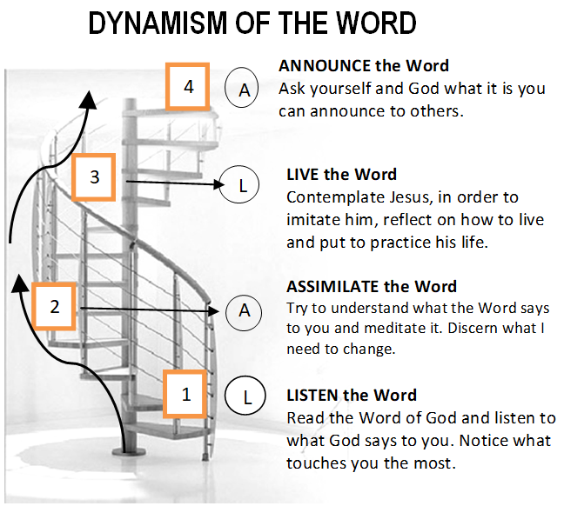
Monday
“Fix your eyes in Jesus” (Heb.12:2)
Jesus has a project, method and objective for our life. Let us seek Him in all our life experiences and lead others to fix their eyes on Jesus.
He is teaching us how to live amidst this chaotic world that’s full of influences and pressures. Human as we are, we tend to easily give in to these forces and live according to our carnal desires for us to be happy and satisfied. Jesus aims for us to imitate Him, and He shows us the best way to conquer these battles with prayer, humility, and obedience to the Father. He is our perfect teacher and master by example, for He too has experienced them in His life. (cf.Jn.13:13) With these virtues, we are able to become strong against temptations and experience bliss as we overcome them.
How are we taking Jesus as our model ?
Tuesday
“I came not to judge the world but to save it.” (Jn.12:47)
Jesus has clarity for what He has been sent, as what His name, “Jesus” meaning “Yahweh saved” reveals. As collaborators of Christ in his mission, we are called to gather the scattered children of God. Before we were born, God chose and trusted us. The way He sees us goes beyond our limitations. He knows perfectly who we are and he knows exactly our capacity--how we can give ourselves to others for His sake. So let us help the church in her mission to restore the lost dignity of God’s children. Thru our collaborative efforts we can help realize the objectives of Christ -- to save mankind.
Are you willing to collaborate with Jesus in the fulfilment of His mission?
Wednesday
“The right time has come and the kingdom of God is near.” (Mk.1:14-20)
Jesus shares with us His passion for the Kingdom in our encounter with Him and with His word that has a transforming power for us to align our thoughts, words, and deeds with His. It is an essential tool to help build the kingdom of God. Let us also share it to others, our prayers and testimonies so that they too may learn how to establish God’s kingdom here on earth.
How are you passionate of the Kingdom of God?What is Jesus inviting you?
Thursday
“I have to preach to them also, because that is why I came.” (Mk.1:38)
The word of God is not only meant for our personal consumption but for everyone most especially for those who are indifferent to Him. God is love and His love is universal that never excludes anyone. God’s kingdom is for everyone. Thus, Jesus went from one town to another, preaching about the Kingdom and healing people.(cf. Mt.4:23;9:35). As Jesus called us, let us invoke the Holy Spirit to descend upon us and to work with us to form new communities of love and compassion. The more we witness for Christ, the greater we receive strength and healing. Let us not be afraid and shy to bring Him to others. Through us, they will be able to find light on their way to find Jesus again and learn to live with the love of Christ in their own special way.
Are you willing to give your time for Jesus? How often do you share Christ to others? Are you willing to accompany others in forming Christ in them?
Friday
“The harvest is large but there are few workers.” (Mt.9:35-38)
Jesus in his vulnerability to the poor, the sick, the lonely, and the oppressed, consequently, puts all of Himself in the mission. Seeing them, He sensed their need of someone to love them, their need to be accepted, to be heard, to be understood, and to be cared for. He then realized that the mission is huge, the necessities are many and is needed to form and call workers to his mission. Also He realized that not everybody understand him and so He chose the twelve (cf.Mt13:11-14). Also He is calling us and is hoping that we too may be like him to show love and concern for others with no boundaries.
How can we accompany others if we only look at our weaknesses? In what way we participate more in helping Him win the faith of our brethren back to God?
Saturday
“And for their sake I consecrate myself, so that they also may be consecrated in the truth.” (Jn.17:1-26)
Jesus’ main task was to form the 12 Apostle until they become teachers. This was his main strategy to establish the kingdom of God and his preferential option for which He consecrated his life.
Our dedication is very essential in the mission because without it, we will find the difficulty in bringing Christ to others. In this accompaniment, our hearts and minds must be congruent with Christ because we can’t give Him if He is not in us. Our collaborative efforts with Him bring the consecration of our life and others as well.
Am I willing to dedicate my life to God? to be taught again and again by Him, in keeping the flame of faith burning in my heart? To whom shall I invest my life

SUNDAY TRANSFIGURATION OF THE LORD
FIRST READING:Daniel 7:9-10,13-14
Psalm 97:1-2,5-6,9
2nd READING: 2 Peter 1:16-19
GOSPEL: Matthew 17:1-9

GUIDELINES FOR PRAYER
July 31 - August 6, 2017
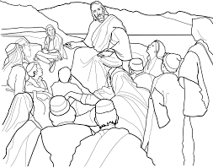

“Jesus sat down and taught them”

General Theme: “Jesus sat down and taught them” (Jn8:2)
General Objective: To deepen how to form Disciples/ Apostles of Christ and to give content in the formation of Apostles.
Specific objective: To contemplate Jesus in the Gospel as a Master/ Formator

