INTRODUCTION

For the past few weeks we’ve been praying about our apostleship, on what is to be an apostle, how to be an apostle in places where we are, and have deepened our understanding about “mission”—that every Christian has a very important role in the mission of the Church. As what Pope Francis said about mission: “My mission of being in the heart of the people is not just a part of my life or a badge I can take off . . . it is something I cannot uproot from my being.” Being an apostle of Christ is our real identity and wherever we are, we carry our mission, to be an apostle and to form others.

This time we will take another step in our journey as an apostle of Christ. It is to experience the ownership that God has over our lives. Being chosen and called by God to work for His vineyard, it is a privilege for us to be part owner and to be tenants of this greatest treasure He has given to us, the Word of God.

This week we will take this as an opportunity to recognize our owner, our maker, the One who loves us the most even in our unlovable moments by giving us His Son to save us and whose love was until the end of time.

What kind of ownership does God has for us?

Monday
God’s ownership is a grace

Luke 13:12-17 ¹² When Jesus saw her, he called out to her, “Woman, you are free from your sickness!” ¹³ He placed his hands on her, and at once she straightened herself up and praised God.¹⁴ The official of the synagogue was angry that Jesus had healed on the Sabbath, so he spoke up and said to the people, “There are six days in which we should work; so come during those days and be healed, but not on the Sabbath!”
¹⁵ The Lord answered him, “You hypocrites! Any one of you would untie your ox or your donkey from the stall and take it out to give it water on the Sabbath. ¹⁶ Now here is this descendant of Abraham whom Satan has kept in bonds for eighteen years; should she not be released on the Sabbath?” ¹⁷ His answer made his enemies ashamed of themselves, while the people rejoiced over all the wonderful things that he did.

A grace to be owned by God is surmountable. When God saw the woman suffering from sickness, he quickly relieved her because He knows she is His.
God’s mercy is abounding to his people. He sees those who suffer from infirmities and indignation. In our following as an apostle, He sees our frailties and hardness, but He is taking us by the hand when we are weak and about to fall because we belong to him.
Am I aware that I am owned by God? Do I allow Jesus to own everything in me including my disabilities?

Tuesday
God called us as His children

1 John 3:1-3 See how much the Father has loved us! His love is so great that we are called God's children—and so, in fact, we are. This is why the world does not know us: it has not known God. ² My dear friends, we are now God's children, but it is not yet clear what we shall become. But we know that when Christ appears, we shall be like him, because we shall see him as he really is. ³ Everyone who has this hope in Christ keeps himself pure, just as Christ is pure.

The reading is inviting us that when we emerge, we shall be like Jesus. Just like a mother delivering a baby; the baby has a hallmark from his father or mother.
Likewise, as an apostle, we are called to be like Jesus in every way. If we know God owns us, we transcend because of love; a love that owns us as His children and a love that does not disclaim even in our disobedience.
Let us allow God to own us so that we can imitate His ways and allow ourselves to realize that we are totally His.
Am I determined to be like Jesus in my everyday life?

Wednesday
(Solemnity of All the Saints)
Happy are you
who are owned by God

Matthew 5:1-12 Jesus saw the crowds and went up a hill, where he sat down. His disciples gathered around him, ² and he began to teach them:
³ “Happy are those who know they are spiritually poor; the Kingdom of heaven belongs to them!
⁴ “Happy are those who mourn;
God will comfort them!
⁵ “Happy are those who are humble; they will receive what God has promised!
⁶ “Happy are those whose greatest desire is to do what God requires; God will satisfy them fully!
⁷ “Happy are those who are merciful to others; God will be merciful to them!
⁸ “Happy are the pure in heart;
they will see God!
⁹ “Happy are those who work for peace; God will call them his children!
¹⁰ “Happy are those who are persecuted because they do what God requires; the Kingdom of heaven belongs to them!
¹¹ “Happy are you when people insult you and persecute you and tell all kinds of evil lies against you because you are my followers. ¹² Be happy and glad, for a great reward is kept for you in heaven. This is how the prophets who lived before you were persecuted.

Are we happy upon knowing that we belong to God and what He has belongs to us? Are we aware that God is calling us deeply to experience how it is to be owned by Him?
Saints are cognizant with this calling. As an apostle; we are called to live by examples like saints as well who showed us what is to be owned and loved by God.We may think it’s impossible but it is not. Saints are experiencing humiliation and infirmities, but they are able to keep their identity because they know who own their lives.
Am I willing to live the way saints did toward holiness?

Thursday
(Commemoration of all the Departed)
God never condemns us

Romans 8:31-35 ³¹ In view of all this,
what can we say? If God is for us, who can be against us? ³² Certainly not God, who did not even keep back his own Son, but offered him for us all! He gave us his Son—will he not also freely give us all things? ³³ Who will accuse God's chosen people? God himself declares them not guilty! ³⁴ Who, then, will condemn them? Not Christ Jesus, who died, or rather, who was raised to life and is at the right side of God, pleading with him for us! ³⁵ Who, then, can separate us from the love of Christ? Can trouble do it, or hardship or persecution or hunger or poverty or danger or death?

Our relationship with God has an ultimate security. He brought us into this world, sustaining us with His words and will preserve us for the world to come. God is going to hold our hand and never would let it go. Even if we let go of his, even if we stumble and attempt to fall, He is going to keep us because He is strong and has made a commitment to us.

Why is it so important to recognize how much I have been loved by God? What difference does this reality can make in my life and in others?

Friday
(Memorial of St. Martin de Porres)
Nothing can separate us
from His love

Romans 8:37-39 ³⁷ No, in all these things we have complete victory through him who loved us! ³⁸ For I am certain that nothing can separate us from his love: neither death nor life, neither angels nor other heavenly rulers or powers, neither the present nor the future, ³⁹ neither the world above nor the world below—there is nothing in all creation that will ever be able to separate us from the love of God which is ours through Christ Jesus our Lord.

It’s not who is going to separate us from our love for Christ but who is going to separate us from Christ’s love for us.
Our love, our following, our faith can fluctuate between hot and cold but not God’s love. If our salvation depends upon the love we have for God, we are doomed. But, our salvation does not depend upon our love for God, rather it depends upon Christ’s love for us.

Saturday
(Memorial of St. Charles Borromeo)
I prepare a place for you.
Own my ways

John 14:1-6 “Do not be worried and upset,” Jesus told them. “Believe in God and believe also in me. ² There are many rooms in my Father's house, and I am going to prepare a place for you. I would not tell you this if it were not so. ³ And after I go and prepare a place for you, I will come back and take you to myself, so that you will be where I am. ⁴ You know the way that leads to the place where I am going.”
⁵ Thomas said to him, “Lord, we do not know where you are going; so how can we know the way to get there?”
⁶ Jesus answered him, “I am the way, the truth, and the life; no one goes to the Father except by me.

How our God truly owns and loving us to
prepare a place for us! Along our way, we can expect all challenges, difficulties, and temptations to come our way and rock our faith, but God will see us through as we believe in Him and in Jesus. Believe when Jesus said “I am the way,” which simply means He would personally leads and guides us everyday. “I am the truth” means He embodies the truth, not by words alone. “I am the life” means he not only shows us the path of life,but he directs us toward it, to the fullness of life.
Let us keep on believing in Him and allow Him to transform our attitudes, actions, and words that would also reflect our desire to be in the place that He is preparing us to be.

Sunday
31st Sunday in Ordinary Time

First Rdg – Malachi 1:14b-2:2, 8-10
Responsorial Psalm – Psalm 131
Second Rdg – 1 Thes 2:7b-9, 13
Gospel – Matthew 23:1-12

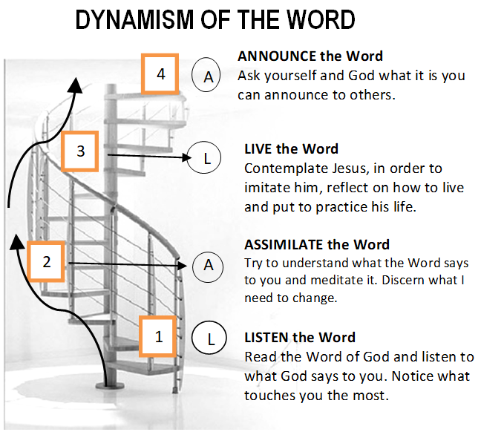
GUIDELINES FOR PRAYER

“Owned by God, loved
by God”

(October 30-November 5, 2017)

General Theme: All I have is yours, and all you have is mine (John 17:10)
General Objectives:
- To experience deeply the ownership of God over our lives.
- To live being conscious that everything I have comes from Him except sin, and to be encouraged to live everything for Him as an apostle.
- To walk with the saints this month as examples having Him as their king.

Specific Objective: To experience the ownership that God has for our lives.

