**INTRODUCTION**

“Enlarge the space of your tent, spread out your tent cloths unsparingly; lengthen your ropes and make firm your stakes” (Isaiah 54:2). This theme is in continuity with our previous NAP and the desire for missionary expansion. This growth and expansion is on-going and we face the beautiful, if somewhat challenging task, to invest our lives in our local communities without losing sight of the bigger horizon.

Seeing the signs of the times, and sensing the urgency of our mission, we understand the importance of the charism entrusted to us by God. As apostles, we recognize that through our charism each one is entrusted with the life of God: Life which is to be transmitted to our brothers and sisters: “We will put all our efforts so that all people “reach the full knowledge of the truth” so that they may be, know and feel themselves as brothers and sisters, children of the same Father, with the same rights and duties. Our highest ideal will be to make of all nations, disciples of Jesus Christ, who may in turn proclaim with their life and word, the Good News of the Kingdom and the wonders of God” ***(Constitutions of the Verbum Dei Missionary Fraternity, no. 16).***

As apostles, we desire to be filled with the same missionary zeal of our founder Jaime Bonet - a zeal to put people in contact with God, to provoke an encounter with Jesus and to have Christ as their only foundation. Jaime is a man in love with Christ and convinced of his mission. This mission has now been entrusted to us and Jesus asks each one “Can I count on you?”

In this area of Missionary Expansion, we can consider the ad-extra and ad-intra dimensions of the VDMFam mission: Ad-extra sees the large harvest field where God is calling us to reach out to: Asia. The horizon of our mission extends to other places that are calling out for the Word of God: Malaysia, China, Vietnam, Japan ... **(NAP 2017-2019)**

God is always with us who will capacitate us to carry out the mission entrusted to us.

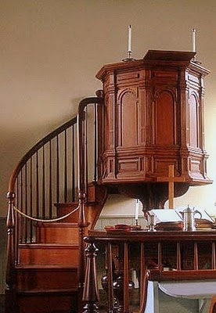**DYNAMISM OF THE WORD**





L

**MONDAY**

***STRETCH OUT YOUR CAPACITIES***

2 “Enlarge the place of your tent, stretch your tent curtains wide, do not hold back; lengthen your cords, strengthen your stakes.3 For you will spread out to the right and to the left; your descendants will dispossess nations and settle in their desolate cities.

***Isaiah 54:2-3***

*God's intention for Verbum Dei Family is to be a forerunner of faith not only in our local community but in other countries as well. We need to stretch our God given capacities to further bring Jesus to as many places as we can in our locality as well as in our neighboring countries. This sounds so big but let us not be intimidated by fear because God will capacitate us to fill the world with faithful men and women. Only when we are stretched, we will fully know what God has in store for us.*

**TUESDAY**

***RESPOND GENEROUSLY***

**19**Therefore go and make disciples of all nations, baptizing them in the name of the Father and of the Son and of the Holy Spirit, **20**and teaching them to obey everything I have commanded you. And surely I am with you always, to the very end of the age.” ***Matthew 28:19-20***

*Our being Christian involves more than simply following Jesus by being His disciple. Christ's call to discipleship includes His call to disciple- making. We are called to help fulfill the Great Commission ,* ***to go to and make disciples of all nations .*** *The One who gives us this command has given us the authority to teach others to obey God's commandments . Let us not put in vain Jesus' trust to us, to continue His work here on earth. Let us not be stingy of our time, talent and treasure to spread our faith. Can He count on you?*

**WEDNESDAY**

***REACH OUT FOR MORE***

**16**I have other sheep that are not of this sheep pen. I must bring them also. They too will listen to my voice, and there shall be one flock and one shepherd. ***John 10:16***

*Can you see the desire of Jesus to bring back in His flock those who do not listen and believe in Him? We have been brought to His flock through His Words, and in the same manner we can bring His other sheep to the flock where we are now. Our preaching and our witnesses are that Word. Can you help fulfill God's desire?*

**THURSDAY**

***RESPOND TO THE NEED***

The VDMFa as a whole, in its complementarity, is an expression of the Verbum Dei in its plenitude and seeks to make visible the being of the Church, in the image of the Trinity, always open to the needs of the world and the signs of the times.

***(VD Constitution 2 Structuring the VD Missionary Family)***

But if anyone has the world's goods and sees his brother in need , yet closes his heart against him, how does God's love abide in him? Little children, let us not love in word or talk but in deed and in truth. ***1John 3:17-18***

*We Verbum Dei family is very rich in the Word of God and formations because of the faithfulness and generosity of the those who have come ahead of us and responded to our needs. How about doing the same to those who come behind us?*

**FRIDAY**

***SENSE THE URGENCY TO PREACH***

**13** for, “Everyone who calls on the name of the Lord will be saved.” **14** How, then, can they call on the one they have not believed in? And how can they believe in the one of whom they have not heard? And how can they hear without someone preaching to them? ***Romans 10:13-14***

*Only when we sense the divine necessity to preach can we answer to the call of Jesus to explain His Word to those who are ignorant of it. Do you sense the urgency to preach?*

**SATURDAY**

***BE A LIGHT***

**47** For this is what the Lord has commanded us: “ ‘I have made you a light for the Gentiles, that you may bring salvation to the ends of the earth.’ ” ***Acts 13:47***

*A lamp is meant to be placed on a stand to give light to everything around it. We are called to illumine others by taking time to interact with people and cultivate relationships, to counter darkness, "so that they may see our good works and give glory to our Father who is in heaven". Start shining where you are now.*

**SUNDAY**

**7th Sunday in Ordinary Time**

**1st Reading:** Leviticus 19:1-2, 17-18

**Responsorial Psalm:** Psalm 103

**2nd Reading:** 1Cor 3:16-23

**Gospel**: Matthew 5:38-48

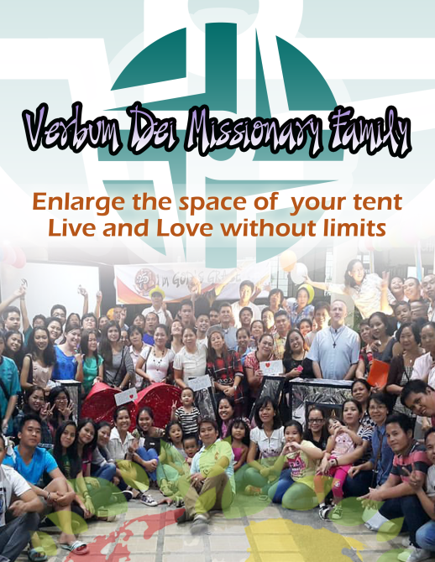





**GUIDELINES FOR PRAYER**



***“Stretch out and lengthen”***



February 13-19, 2017

**General Theme:** Enlarge the space of your tent. (Isaiah 54:2)

**General Objectives:**

To introduce the National Apostolic Project (NAP) to the VDMFa inviting them to own and personalize this project of God for the Verbum Dei Missionary Family Philippines for the next three (3) years.

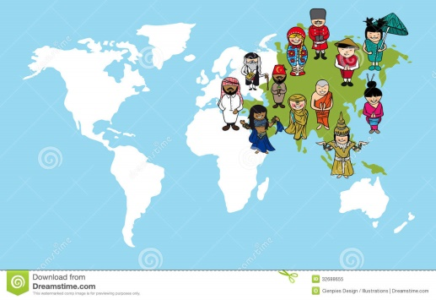



**Objective of the week:**

To enlarge our tent is to take a further step in continuing to form apostles outside Philippines (ad extra ASIA)