**INTRODUCTION**

A joyful New Year to us Verbum Dei Family!

We start this year with a grateful heart to the Trinity and to our Mother Mary for their great mercy to each one of us as one family and for the gift of this new life ahead.

We begin this journey of a new year by recalling our personal experiences of how God manifested His love for us through the Verbum Dei Family. A God becoming human is a clear proof of His love for humankind. A love so humble that He chose to be born from a human mother in a manger. A love that brought us out from slavery and darkness with His own blood.

*“How great is our Father God, of whom every family in heaven and on earth is named (Ephesians 3:15), as He looks at each of us and our families! He begets us as children in the Son and gives us the Holy Spirit, entering into the bosom of the Trinitarian life and making us participate in his personal and family love.”* (Quote from the book: “Familiares de Dios”)

Because of love it made us belong in His Trinitarian family, the Father, the Son and the Holy Spirit, not by chance but according to His plan. And this love brought us hope, peace and joy that we want to share with others. As what Pope Francis said in his Message for the Celebration of the Fiftieth World Day of Peace: “*They too are part of our “family”; they too are our brothers and sisters. The politics of nonviolence have to begin in the home and then spread to the entire human family. “Saint Therese of Lisieux invites us to practise the little way of love, not to miss out on a kind word, a smile or any small gesture which sows peace and friendship. An integral ecology is also made up of simple daily gestures that break with the logic of violence, exploitation and selfishness”.*”

As a Verbum Dei Family, like Mother Mary, God is asking our help to give Him life, to be *the Word became flesh.* (John 1:14) To take on God’s plan, for our brothers and sisters, even without knowing what are the consequences, to have the willingness to cooperate, and to place our lives in God’s hands.

As we welcome this new year, let us also welcome our brothers and sisters in our family Verbum Dei.

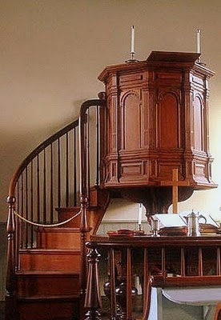**DYNAMISM OF THE WORD**





L

**MONDAY**

***JESUS IMMERSED IN OUR HUMANITY***

***(Sts. Basil the Great and Gregory Nazianzen, Bishops and Doctors)***

7 He announced to the people, "The man who will come after me is much greater than I am. I am not good enough even to bend down and untie his sandals. 8 I baptize you with water, but he will baptize you with the Holy Spirit."

9 Not long afterward Jesus came from Nazareth in the province of Galilee, and was baptized by John in the Jordan. 10 As soon as Jesus came up out of the water, he saw heaven opening and the Spirit coming down on him like a dove. 11 And a voice came from heaven, "You are my own dear Son. I am pleased with you." ***(Mark 1:7-11)***

*Being baptized means Jesus has fully entered into our human condition. To immerse oneself in the water, Jesus showed his desire to enter into our situations. Jesus is inviting us to immerse in our humanity, to enter fully into the depths of our humanity. By doing so, we allow God to fully love us, to embrace us.*

**TUESDAY**

***GOD HAS CONQUERED OUR DARKNESS***

***(St. Genevieve / Most Holy Name of Jesus)***

4 Joseph went from the town of Nazareth in Galilee to the town of Bethlehem in Judea, the birthplace of King David. Joseph went there because he was a descendant of David. 5 He went to

register with Mary, who was promised in marriage to him. She was pregnant, 6 and while they were in Bethlehem, the time came for her to have her baby. 7 She gave birth to her first son, wrapped him in cloths and laid him in a manger -- there was no room for them to stay in the inn. *(****Luke 2:4-7****)*

*The birth of Jesus in a manger was the greatest proof of God’s love for humankind. His humble way of coming to the world brought hope within us that in the middle of challenges, darkness that we have encountered, peace and light will always come. Jesus is the Prince of Peace and the Light in our path. If we allow Him to be born in “our manger”, we will always find peace, and light will shine on us.*

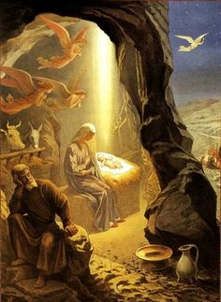

**WEDNESDAY**

***CHOSEN ACCORDING TO GOD’S PLAN***

***(St. Elizabeth Ann Seton)***

11 All things are done according to God’s plan and decision; and God chose us to be his own people in union with Christ because of his own purpose, based on what he had decided from the very beginning. 12 Let us, then, who were the first to hope in Christ, praise God’s glory! 13 And you also became God’s people when you heard the true message, the Good News that brought you salvation. You believed in Christ, and God put his stamp of ownership on you by giving you the Holy Spirit he had promised. 14 The spirit is the guarantee that we shall receive what God has promised his people, and this assures us that God will give complete freedom to those who are his. Let us praise his glory! *(****Ephesians 1:11-14****)*

*We were destined to the loving plan of God from the very beginning. Plan that Christ would be in our midst, with his cross and his resurrection, to show us the love of the Father who has called us and of course, wherever the Son is, the Spirit will be given. From the Spirit we have received these gifts: faith, hope, love, miracles and healings. The most obvious proof that we have become children of God.*

**THURSDAY**

***CHOSEN TO BE HIS OWN SPECIAL PEOPLE***

***(St. John Neumann)***

6 Do this because you belong to the Lord your God. From all the peoples on earth he chose you to be his own special people. 7 “The Lord did not love you and choose you because you outnumbered other peoples; you were the smallest nation on earth. 8 But the Lord loved you and wanted to keep the promise that he made to your ancestors. That is why he saved you by his great might and set you free from slavery to the king of Egypt. 9 Remember that the Lord your God is the only God and that he is faithful. He will keep his covenant and show his constant love to a thousand generations of those who love him and obey his commands ***(Deuteronomy 7:6-9)***

*God loves humankind. Because of that love, God fulfilled His promise for His people and God chooses those who will be granted a closer relationship with him through His Son, Jesus. For in Christ we obtain freedom, sealed by His blood. God has been faithful to us. In what way can we show our gratefulness to the Trinity?*

**FRIDAY**

***BE JESUS IN FLESH FOR MANY***

***(St. Andre Bessette)***

16 So they hurried off and found Mary and Joseph and saw the baby lying in the manger. 17 When the shepherds saw him, they told them what the angel had said about the child. 18 All who heard it were amazed at what the shepherds said. 19 Mary remembered all these things and thought deeply about them. 20 The shepherds went back, singing praises to God for all they had heard and seen; it had been just as the angel had told them.

21 A week later, when the time came for the baby to be circumcised, he was named Jesus, the name which the angel had given him before he had been conceived. ***(Luke 2:16-21)***

*Let us learn from our Mother Mary. With all humility she accepted the opportunity to make Jesus flesh. God needed her cooperation to give him life. Through her yes to God's will, salvation came to our lives. As a member of the family of God, we are invited to take on God's plan for the salvation of our brothers and sisters. To be Jesus in flesh so that, like the shepherds, they too can "sing praises to God for all they had heard and seen."*

**SATURDAY**

***BE A FAMILY WHO INTRODUCE FAITH***

***(St. Raymond of Penafort, Priest)***

22 The time came for Joseph and Mary to perform the ceremony of purification, as the Law of Moses commanded. So they took the child to Jerusalem to present him to the Lord, 23 as it is written in the law of the Lord: "Every first-born male is to be dedicated to the Lord." 24 They also went to offer a sacrifice of a pair of doves or two young pigeons, as required by the law of the Lord.

25 At that time there was a man named Simeon living in Jerusalem. He was a good, God-fearing man and was waiting for Israel to be saved. The Holy Spirit was with him 26 and had assured him that he would not die before he had seen the Lord's promised Messiah. 27 Led by the Spirit, Simeon went into the Temple. When the parents brought the child Jesus into the Temple to do for him what the Law required **(Luke 2:22-27)**

*God has chosen us to put His word and life in this family in order to take care and to grow. So that through us we may be able to introduce others in Faith and to build a loving relationship with the Trinity. This is what a family all about. A family living with and for the Word in order to teach others to do the same.*

**SUNDAY**

**THE EPIPHANY OF THE LORD**

**1st Reading:** Isaiah 60:1-6

**Responsorial Ps:** Psalm 72

**2nd Reading:** Ephesians 3:2-3a, 5-6

**Gospel:** Matthew 2:1-12

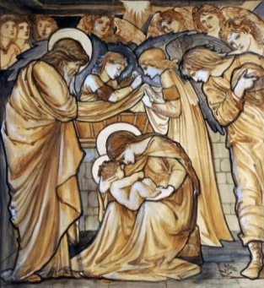



**GUIDELINES FOR PRAYER**



***“VDMFa: God has chosen you out of love.”***



January 2-8, 2017

**General Theme:** Enlarge the space of your tent.

**General Objectives:**

That the disciples renew their experience to be members of this great Family that God has gathered and has chosen in His name in order to welcome many people and continue to express His Trinitarian and Missionary identity through this Family.

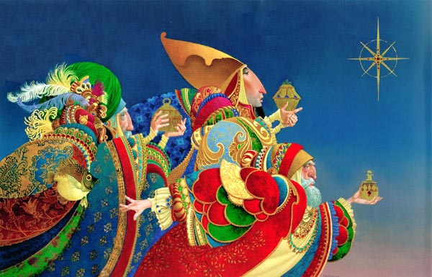

**Objective of the week:**

To refresh the experience that God has chosen us as His family.