INTRODUCTION

The Verbum Dei Family was born because of a man with a heart on fire for Christ, a man who understood the dream of Christ to heal the suffering humanity of His body, and a man whose heart was inflamed with love for the evangelization of all peoples—Fr. Jaime Bonet. He spent many hours in front of the tabernacle, in dialogue with the Trinity and Mother Mary. Through this fire, God’s love was shared in the mission, announcing and bringing fire to the world in order to warm the cold and lukewarm hearts.
Fr. Jaime responded to the desire of Christ to bring fire to the earth by keeping the flame of divine life and love alive in his heart and encouraging everyone to have devotion to the four sources of our spirituality: the Holy Trinity, the Eucharist, the Mystical Body of Christ, and Mother Mary.
Even though Fr. Jaime is not with us anymore, his same spirituality and mission will be carried on in the family where peoples from all the five continents of every reality participate in living out and propagating the Kingdom of God, forming apostles of Christ, and creating evangelizing communities.
May his spiritual legacy inspire us to continue fulfilling Jesus’ dream for Verbum Dei—to live and propagate God’s Kingdom to a world that is in need of it.

How can we fulfil that dream of Jesus for Verbum Dei Family toward God’s people?
What can we contribute to the mission of the Church in propagating the Word of God?

MONDAY
To dream with my family

Isaiah 60:1-9
Arise, Jerusalem, and shine like the sun; The glory of the Lord is shining on you! Other nations will be covered by darkness, But on you the light of the Lord will shine; The brightness of his presence will be with you. Nations will be drawn to your light, And kings to the dawning of your new day. Look around you and see what is happening: Your people are gathering to come home! Your sons will come from far away; Your daughters will be carried like children. You will see this and be filled with joy; You will tremble with excitement. The wealth of the nations will be brought to you; From across the sea their riches will come. Great caravans of camels will come, from Midian and Ephah. They will come from Sheba, bringing gold and incense. People will tell the good news of what the Lord has done! All the sheep of Kedar and Nebaioth will be brought to you as sacrifices and offered on the altar to please the Lord. The Lord will make his Temple more glorious than ever. What are these ships that skim along like clouds, Like doves returning home? They are ships coming from distant lands, bringing God's people home. They bring with them silver and gold to honor the name of the Lord, the holy God of Israel, who has made all nations honor his people.

Our contemplative-missionary spirituality is not only in function of our personal sanctification, but of the sanctification of the life of many and at the service of the whole Church of Christ and humanity. Our life, centered in the person, life and Gospel of Christ, necessarily acquires the fundamental spirituality of Jesus in his prayerful attitude that makes of the Man-God an adorer of the Father and, from the Father, a gift and offering for the whole humanity. Guided by the same Spirit of Jesus, we are sent in the same mission to announce the Kingdom of God. (VD Statutes #26)

As Verbum Dei, prayer has always been the essential way to draw close to the living fire and listen to the Trinity speaking to us in a personal way. We must never get tired of approaching Christ through His Word so we can continue to fulfil God’s dream for His people—that all may rise, hope again, and come home filled with joy; that all may see the light and experience the richness of His love.

What are those things that we are willing to give up for God’s dream for our community, our life, and His people?
TUESDAY
Give the Word with conviction

Isaiah 49:1-6
Listen to me, distant nations, you people who live far away! Before I was born, the Lord chose me and appointed me to be his servant. He made my words as sharp as a sword. With his own hand he protected me. He made me like an arrow, sharp and ready for use. He said to me, “Israel, you are my servant; because of you, people will praise me.” I said, “I have worked, but how hopeless it is! I have used up my strength, but have accomplished nothing.” Yet I can trust the Lord to defend my cause; he will reward me for what I do. Before I was born, the Lord appointed me; he made me his servant to bring back his people, to bring back the scattered people of Israel. The Lord gives me honor; he is the source of my strength. The Lord said to me, “I have a greater task for you, my servant. Not only will you restore to greatness the people of Israel who have survived, but I will also make you a light to the nations—so that all the world may be saved.”

The proclamation of the Word of God, preceded and accompanied by prayer and witness of life, will always be the best means for the propagation of the faith. We will sow the good seed of the Word in all fields, trusting in the growth that God gives, knowing that the Word, like “the rain which falls from heaven will not return empty,” because certainly, “the Word of God is alive and effective and sharper than any two-edged sword.” (VD Statutes # 38)

To give the Word of God with conviction, we must spend longer time for prayer and assimilation in order to experience the love of the Trinity and not merely to know it intellectually. Let us allow the Word to give us light, nourish us, fills us, and encourage us to go on because preaching without prayer is like a noisy gong or a clanging bell; there will be no love and deep awareness of the mission of Christ and no strength to face temptations.

How much time do I give for prayer?

WEDNESDAY
Be doer of the Word
and not hearer only

Luke 6:46-49
“Why do you call me, ‘Lord, Lord’ and yet don’t do what I tell you? Anyone who comes to me and listen to my words and obeys them - I will show you what he is like. He is like a man who, in building his house, dug deep and laid the foundation on rock. The river flooded over and hit house but could not shake it, because it was well built. But anyone who hears my words and does not obey them is like a man who built his house without laying a foundation; when the flood hit that house it fell at once - and what a terrible crash that was!

Our Verbum Dei missionary identity is configured by the habitual practice of the four exercises: exercise of prayer, the exercise of fraternal love, the exercise of the cross-humility, and the exercise of the ministry of the Word. From the practice of these exercises, all the means of spirituality of the missionary family are developed: personal prayer and in community centered in the Word of God, practices and gestures of faith that help a life of faith, frequent participation in the sacraments of the Church, review of the day, devotion to Mary, retreats and spiritual exercises, spiritual accompaniment, revision of life, spiritual reading, as well as other means of spiritual life in the Church. (VD Statutes # 31-32)

Fr. Jaime believed that “we have saved someone when we have taught him or her to pray. Christ will have a new disciple when he or she, through prayer, ‘comes to know him’ personally, not by hearsay but by personal experience.” When a person recognizes who is the real source of security, he or she will go toward Jesus to draw courage to fight and get out of the slavery of sins.

Is my life built on the rock, which is Jesus?
THURSDAY
Live according to moral truth and upright character

Luke 6:43-45
“A healthy tree does not bear bad fruit, nor does a poor tree bear good fruit. Every tree is known by the fruit it bears; you do not pick figs from thorn bushes or gather grapes from bramble bushes. A good person brings good out of the treasure of good things in his heart; a bad persons brings bad out of his treasure of bad things. For the mouth speaks what the heart is full of.”

Union with God in Christ is the greatest source of energy, fidelity, enthusiasm, and joy of each member of the VDMFamily. From this union arises the true following of Christ and in the same way the realization of an authentic Christian family. The personal encounter and familiar relationship of affectionate intimacy with God ensures that our ministry of the Word be always accompanied by a clear testimony of life according to the Gospel. (VD Statutes # 25).

There's a saying that you will know a tree by its fruit. Likewise a person will produce good or bad fruit depending on what is sown in the heart. Character, like fruit, doesn't grow overnight; it takes a lifetime. Through our daily personal encounter with Jesus, he purifies our mind and our spirit in order to become the tree that produces good fruits—fruits of love, joy, peace, patience, kindness, goodness, faithfulness, humility, and self-control. Good fruit is the result of sound living—living according to moral truth and upright character. How do we avoid becoming bad fruit? By being true—true to God, to his word, and to his grace. This takes character. Those who are true to God know that their strength lies not in themselves but in God who supplies the grace they need to live as his disciples.

Do you cultivate good fruit in your life and reject whatever produces bad fruit?
FRIDAY
Follow with and for love

John 21:18-19
I am telling you the truth: when you were young, you used to get ready and go anywhere you wanted to; but when you are old, you will stretch out your hands and someone else will tie you up and take you where you don't want to go.” (In saying this, Jesus was indicating the way in which Peter would die and bring glory to God.) Then Jesus said to him, “Follow me!”

God is love (1 John 4:16). His love is unconditional, unmerited, and without limit. It lasts forever. It’s the beginning and the end; it's the reason God created us and why he wants us to be united with him. It is the essence of what it means to be a Christian—one who knows God's love and forgiveness and who loves God in return with all one's heart, soul, mind, body, and strength. God's love heals and transforms our lives and frees us from fear, selfishness, and greed. It draws us to the very heart of God and it compels us to give to him the best we have and all we possess—our gifts, our time, our resources, our full allegiance, and our very lives. Paul the Apostle tells us that God’s love has been poured into our hearts through the Holy Spirit which has been given us (Romans 5:5). The practice of love will take root in life and the person will no longer be the patron of his or her own life.

Do you allow God's love to change and transform your heart? Do you see God’s love in His calling to follow Him?

SATURDAY
Love as He has loved

John 15:12-19
My commandment is this: love one another, just as I love you. The greatest love you can have for your friends is to give your life for them. And you are my friends if you do what I command you. I do not call you servants any longer, because servants do not know what their master is doing. Instead, I call you friends, because I have told you everything I heard from my Father. You did not choose me; I chose you and appointed you to go and bear much fruit, the kind of fruit that endures. And so the Father will give you whatever you ask of him in my name. This, then, is what I command you: love one another. If the world hates you, just remember that it has hated me first. If you belonged to the world, then the world would love you as it’s own. But i chose you from this world and you do not belong to it; that is why the world hates you.
The unconditional love of God, who first loved us, brings us to desire that all His children may participate in the family of God. His love for humanity, is a love of a father and mother, a faithful spouse, a brother and friend, and lays the foundation of the warmth of home and the gratuity of relationships that unite the families of God. (VD Statutes # 56)

Friendship with God certainly entails a loving relationship which goes beyond mere duty and obedience. The distinctive feature of Jesus' relationship with his disciples was his personal love for them. He loved his own to the end (John 13:1). His love was unconditional and wholly directed to the good of others. Like a true lover, Jesus gives the best he can offer and is willing to sacrifice everything he has for the beloved. That's the nature of true friendship and love—the willingness to give all for the beloved. He wants us to love one another just as he loves us, whole-heartedly and without reserve. If we open our hearts to his love and obey his command to love our neighbor, then we will bear much fruit in our lives, fruit that will last for eternity.

Do you wish to be fruitful and to abound in the love of God?

SUNDAY
Sixteenth Sunday in Ordinary Time

First Reading: Wisdom 12:13, 16-19
Psalm: Ps 86:5-6, 9-10, 15-16
Second Reading: Romans 8:26-27
Gospel: Matthew 13:24-43

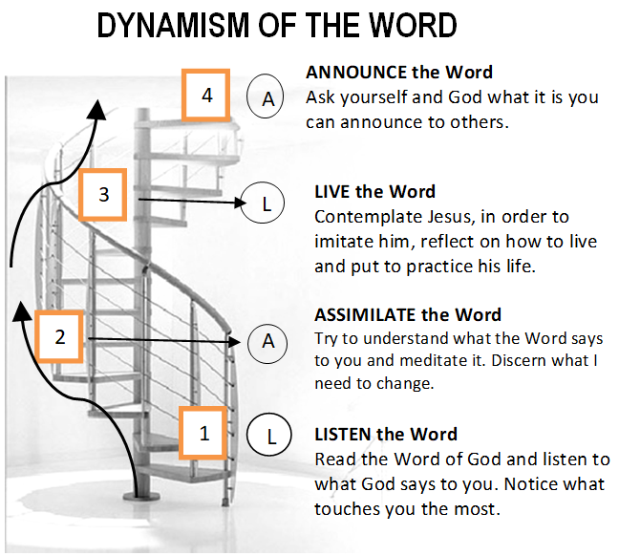

GUIDELINES FOR PRAYER

“The mission is not something; it is someone.”
(Fr. Jaime Bonet)

July 17-23, 2017

General Theme: Here I am with the children God has given me.
General Objective: To learn to have an apostolic prayer; to identify and own the accompaniment of specific people

Objective of the week: To learn from Jesus how to carry out that same dream He has for us as Verbum Dei to all God’s children

