INTRODUCTION

This week, we are invited to deepen more on learning to have an apostolic payer—to identify and own the accompaniment of specific people. We are invited to remember the time when we first heard about our founder Fr. Jaime Bonet; let us see in his life how he lived, how he had that apostolic prayer, and how he owned the accompaniment of people. How did he have the conviction to do it? In the book The Herald of the Evangelizer, Why do I Evangilize? we could see how convinced and committed Jaime was to collaborate and participate with his entire mind, heart, and strength in the most effective way for the redemption and liberation of all people. In his life we see that even sickness did not stop him to pray, to be faithful, to spend time and have his presence, to be patient and kind, to have sincere intention, and to even participate as much as he could. Let us remember in one moment in the life of Jaime when he said, I need to preach and to do the mission.

Now that he is with our Father in heaven, he can intercede for us all the more so that we may be able to sustain, to move, and to work for God’s children that were entrusted to us. He had the great vision to renew the face of the earth—to change hatred into love, sadness to joy, anguish and despair to optimism and hope, sickness and death into life and resurrection—because he was eager to see a radiant light dawn on so may gloomy faces.

Let us see in the life of Jaime how he accompanied God’s children that God entrusted to him (which includes us).

MONDAY
God’s children need my prayer

John 17:20-21, 24 I pray not only for them but also for those who believe in me because of their message. I pray that they may all be one. Father, you have given them to me and I want them to be with me where I am.

James 5:16 So then confess your sins to one another and pray for one another so that you will be healed. The prayer of a good person has a powerful effect.

I would like to say to Verbum Dei, since I feel it as my great responsibility before God that Verbum Dei without prayer will not exist, nor preach, nor expand, nor can it grow. —Jaime Bonet

Prayer is a powerful tool that heals, unites, refreshes, and makes wonders. When we pray for one another we see how the Lord moves in the lives of others, in the whole Church, in our community, in our own family, and in our very own lives as well. According to Fr. Jaime, community cannot sustain without prayer, and without prayer there is no mission.

Prayer at first, heals our inward being, thereafter we can’t help but embrace its outward dimension, that is to pray for someone else’s concerns and benefits. When we learn how to pray, our life would never be the same again because that’s how prayer is, it is our encounter of Jesus himself and we can’t anymore afford to lose that encounter and the beautiful experiences we shared with him together with our brothers and sisters.

Have we prayed for someone (member of the Catholic Church, our community, or our family) today?

TUESDAY
God’s children need my faithfulness

Hebrews 3:1-2 My Christian brothers, who also have been called by God! Think of Jesus, whom God sent to be the High Priest of the faith we profess. He was faithful to God, who chose him to do this work, just as Moses was faithful in his work God’s house.

1 Corinthians 4:2 The one thing required for such a servant is that he be faithful to his master.

1 Samuel 12:24 Only fear Yahweh and serve him faithfully with all your heart, for you have seen the wonderful things he has done for you.

Jesus taught us to be faithful, for he was the one who showed us how to be faithful to the Father. Faith allows us to see wonderful and beautiful things that the Lord has done and allows others to move through us. Faith makes the church, the community, and our family alive and keep the fire burning. Faith begets faithfulness; we have been witnesses of the faithfulness of many servants of our Lord Jesus Christ (to name a few: our founder Fr. Jaime, Pope Francis, and St. Therese of the Child Jesus) and even in the lives of our co-disciples in the VD Family. God sees and is pleased with the faithfulness we have to the very little things that we contribute to the needs of our community.

Do you recognize how God is pleased with your contribution to the community, to the Church, and to your own family?

WEDNESDAY
God’s children need my time and presence

John 4:40-41 When the Samaritans came to him, they invited him to stay with them; and he stayed there two days. Many more began to believe in him because of his word.

Psalm 90:12 Teach us how short our life is so that we may become wise.

Looking on the disposition of Jesus, he was the one who teaches us to spend time and be present, to stay with the people who needs our helping hand especially in our community, to spend our lives and our time wisely that it may be lived in its fullness. Our presence and testimony of life impact a change in the community, the whole church, and within our family where we are, for we are unique and irreplaceable where we belong. There is another joy to discover in the work for communitarian goal of sharing the good news that God taught us.

Do you spend time and be present when it calls for us to be wherever we are—at home, at work, or in the community?

THURSDAY
God’s children need my patience and kindness

John 10:11 I am the good Shepherd, who is willing to die for the sheep. When the hired man, who is not a shepherd and does not own the sheep, sees a wolf coming, he leaves the sheep and runs away; so the wolf snatches the sheep and the scatters them.

1 Peter 4:2 Shepherd the flock which God has entrusted to you, guarding it not out of obligation but willingly for God’s sake; not as one looking for a reward but with generous heart, do not lord it over those in your care, rather be an example to your flock. Then, when the hief Shepherd appears, you will be given a crown of unfading glory.

Ephesians 4:2 Be always humble, gentle and patient. Show your love by being tolerant with one another. Do your best to preserve the unity which the Spirit gives by means of peace that binds you together.

We need to understand that we are totally different in our responses to the many different concerns in our community, Church, or our family, but yet each one of us is encouraged to sustain our solidarity in the midst of all these diversity through the teachings of Jesus Christ and his way of life. Like Christ who is a good Shepherd, who is patient and kind to us, let us share the kind of kindness and patience we received from Christ so that many may be able to see. It is Jesus our good Shepherd who leads us the way.

Are we patient and kind in our dealings with God’s children?

FRIDAY
God’s children need my affection and sincere intention

Jeremiah 9:23-24 The Lord says, Wise men should not boast of their wisdom, nor strong men of their strength, nor rich men of their wealth. If anyone wants to boast, he should boast that he knows and understands me, because my love is constant, and I do what is just and right. These are the things that please me.

Matthew 6:1-2 Make certain you do not perform your religious duties in public so that people will see what you do. If you do these things publicly, you will not have any reward from your Father in heaven. So when you give something to a needy person, do not make a big show of it, as the hypocrites do in the houses of worship and on the streets. They do it so that people will praise them. I assure you, they have already been paid in full.

If you exist, Lord, make me happy. —Jaime Bonet

Sincerity and good intentions in doing the works that Christ entrusts to us gives us pure joy, the joy that can never be bought or received elsewhere. It is our consolation and reason that we move and work more for this great joy we received. How happy are we when we become bridges for others to know and encounter Christ.

Have I done my duty or duties that I commit to without wanting for anything in return? How sincere am I in my intentions?

SATURDAY
God’s children need my active participation

Acts 4: 32 The group of believers was one in mind and heart. No one said that any of his belongings was his own, but they all shared with one another everything they had. With great power the apostles gave witness to the resurrection of the Lord Jesus, and God poured rich blessings on them all. There was no one in the group who was in need.

Acts 6: 4 We ourselves then, will give our full time to prayer and preaching.

CCC 1914 Participation is achieved, first of all by taking charge of the areas for which one assumes personal responsibility: by the care taken for the education of his family, by conscientious work and so forth, man participates in the good of others and of society.

To not evangelize would be equivalent to burying the talents that God has entrusted to me, for myself, and for everyone, to usurp the temporal and eternal bread of millions of brothers and sisters, to become a voluntary accomplice of the wretchedness, malnutrition, lack of culture, and death of most of humanity on the face of the earth. —Jaime Bonet

Participating in the mission, in the smallest part we do, is not put into waste, instead it brings satisfaction and happiness, for in participating we embrace God’s own children.

Sometimes we are hesitant to participate and give all we can give because we are afraid to be personally responsible with the mission or to where we committed, not realizing that when we do not own the mission we hinder our own growth in spirit, in wisdom, and in love.

Have I given my commitment and accepted my personal responsibility to where I wanted to give my effort on the committee of community?

SUNDAY
The Fourteenth Sunday in Ordinary Time

1st Reading: Zechariah 9:9-10
Psalm: Ps 145: 1-2, 8-11, 13-14
2nd Reading: Romans 8:9, 11-13
Gospel: Matthew 11:25-30

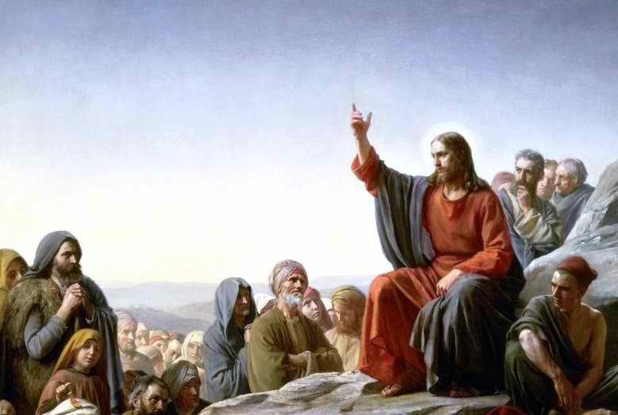

GUIDELINES FOR PRAYER

“Here I am with the children God has given me”
3-9 July, 2017

General Theme:
Here I am with the children God has given me
General Objective:
To learn to have an apostolic prayer—to identify and own the accompaniment of specific people

Objective of the week:

To have that gaze and understanding from Jesus as to what God’s children of today needs

