INTRODUCTION

We have just received the Holy Spirit, the third person in the Holy Trinity. Jesus, the second person of the Blessed Trinity shows us the authentic love of the Father through His mercy and compassion. Jesus taught us to establish filial relationship with the Father because God is very genuine with His love. He promised us to not leave abandoned; that is why he promised us the Holy Spirit to empower us to continue with our journey with Him. The Holy Spirit opens our hearts and minds to the truth. Because of Him, we are able to know and love God our Father and to know more about Jesus our Savior.
We are all invited to pray fervently so that the Holy Spirit will continue to dwell in us and strengthen our faith with the word of God and bring His message to our families and neighbors.
Are you ready to live your Christian faith?
Are you willing to take up your challenge?
In what way can you continue the Christian mission?

MONDAY
It activates what we already received in our Baptism and Confirmation
That is why I am reminding you to fan into a flame the gift of God that you possess through the laying on of my hands. God did not give us a spirit of timidity, but the Spirit of power and love and self-control. So you are never to be ashamed of witnessing to our Lord, or ashamed of me for being his prisoner; but share in my hardships for the sake of the gospel, relying on the power of God. (2 Timothy 1:6-8)

God the Father is the Creator—He made us because of His love and He wanted us to experience His love on our life. The love of the Father is more concrete through Jesus Christ. Before Jesus ascended to heaven, He promised us the Holy Spirit to be with us and to guide us wherever we may be. We are baptised and we have received the Holy Spirit through the Sacrament of Confirmation. Our life as living witnesses of the Gospel confirms that we are God’s children as the Holy Spirit is working and making the word of God become flesh again in us.

TUESDAY
It activates the gift of God that makes us free from being paralyzed and from being just beggars

Now Peter and John were going up to the temple area for the three o’clock hour of prayer.*2ª And a man crippled from birth was carried and placed at the gate of the temple called “the Beautiful Gate” every day to beg for alms from the people who entered the temple.3When he saw Peter and John about to go into the temple, he asked for alms.4But Peter looked intently at him, as did John, and said, “Look at us.”5He paid attention to them, expecting to receive something from them.6* Peter said, “I have neither silver nor gold, but what I do have I give you: in the name of Jesus Christ the Nazorean, [rise and] walk.”^{b}7Then Peter took him by the right hand and raised him up, and immediately his feet and ankles grew strong.8He leaped up, stood, and walked around, and went into the temple with them, walking and jumping and praising God.^{c}9When all the people saw him walking and praising God,10they recognized him as the one who used to sit begging at the Beautiful Gate of the temple, and they were filled with amazement and astonishment at what had happened to him. (Acts 3:1-10)

We, the Verbum Dei disciples, have been receiving a lot from the table of our community, and for that reason we are very blessed. Sometimes we are like the paralyzed man who waits for someone’s aid. For instance, we listen to the sharing and testimonies of God’s word but don’t have the initiative to share to others the spiritual food that was received. Let us keep in mind that abundance is not limited to what we have received but also what we give for the sake of Christ and for the salvation of others.

WEDNESDAY
It activates the gift of God that goes beyond serving at the table to serve the Word of God

2* So the Twelve called together the community of the disciples and said, “It is not right for us to neglect the word of God to serve at table.*3Brothers, select from among you seven reputable men, filled with the Spirit and wisdom, whom we shall appoint to this task,4whereas we shall devote ourselves to prayer and to the ministry of the word.”5The proposal was acceptable to the whole community, so they chose Stephen, a man filled with faith and the holy Spirit, also Philip, Prochorus, Nicanor, Timon, Parmenas, and Nicholas of Antioch, a convert to Judaism.6^{b} They presented these men to the apostles who prayed and laid hands on them.*7The word of God continued to spread, and the number of the disciples in Jerusalem increased greatly; even a large group of priests were becoming obedient to the faith. (Acts 6:2-7)

We are fortunate when we have the courage to spread the kingdom of God on our day-to-day affairs. Let us make the early Christians our role model in following Christ who had the enthusiasm to be of service for others and to the point of death to defend their faith. Let us spread out and be the light and the salt of the earth.

THURSDAY
It activates the gift of God that goes beyond the fears of death

8* Now Stephen, filled with grace and power, was working great wonders and signs among the people.9Certain members of the so-called Synagogue of Freedmen, Cyrenians, and Alexandrians, and people from Cilicia and Asia, came forward and debated with Stephen,10but they could not withstand the wisdom and the spirit with which he spoke.^{d}11Then they instigated some men to say, “We have heard him speaking blasphemous words against Moses and God.”^{e}12They stirred up the people, the elders, and the scribes, accosted him, seized him, and brought him before the Sanhedrin.13They presented false witnesses* who testified, “This man never stops saying things against [this] holy place and the law.14For we have heard him claim that this Jesus the Nazorean will destroy this place and change the customs that Moses handed down to us.”^{f}15All those who sat in the Sanhedrin looked intently at him and saw that his face was like the face of an angel. (Acts 6:8-15)

It is important for us Christians to become the bearers of God’s love. Jesus is no longer physically among us but He promised us the Holy Spirit to be with us all through our Christian journey. With our response to this invitation, we make the word become flesh again. Let us not be shy or hesitant to give what we have received in the community and let us help our brothers and sisters find Christ in their lives.

FRIDAY
It activates the gift of God that goes beyond ugly consequences of the mission and continues to preach the Word of God

1Now Saul was consenting to his execution.ª
Persecution of the Church. On that day, there broke out a severe persecution* of the church in Jerusalem, and all were scattered throughout the countryside of Judea and Samaria, except the apostles.*2Devout men buried Stephen and made a loud lament over him.3Saul, meanwhile, was trying to destroy the church;* entering house after house and dragging out men and women, he handed them over for imprisonment.^{b}
Philip in Samaria.4Now those who had been scattered went about preaching the word.^{c}5Thus Philip went down to [the] city of Samaria and proclaimed the Messiah to them.^{d} (Acts 8:1-5)

There are many brothers and sisters around us that are thirsty for Christ. Will we remain insensitive to their need? As Christ’s witnesses, it is our duty to accompany them. God has given the charism to work for His kingdom to the far corners of the world. We should never give up on Christ because He didn’t even give up on us. He entrusted this mission to us. Let us invite the Holy Spirit to continue working in us and give us the gift to touch the lives of others so that with the help of the Holy Spirit they too may know and proclaim about Christ.

SATURDAY
It activates the gift of God that goes beyond difference

5Thus Philip went down to [the] city of Samaria and proclaimed the Messiah to them.^{d}6With one accord, the crowds paid attention to what was said by Philip when they heard it and saw the signs he was doing.7For unclean spirits, crying out in a loud voice, came out of many possessed people, and many paralyzed and crippled people were cured.^{e}8There was great joy in that city. (Acts 8:5-8)

To believe in Christ is to continue His mission which he has entrusted to the church. We have nothing to worry about what and how to do with the mission. God wants to be with us, that is why he sends us the Holy Spirit to be with us all the way. What is essential in the mission is commitment. A committed person never complains in any circumstance along the way, but he is rather happy to work and be a partner with Christ (as what a saint said, “the more to suffer, the more to offer”). It is the Holy Spirit that works with Christ.

SUNDAY
Solemnity of the Most Holy Body and Blood of Christ (Corpus Christi)
1st Reading – Dt 8:2-3, 14-16
Responsorial Psalm – Ps 147:12-13, 14-15, 19-20
2nd Reading – 1 Cor 10:16-17
Gospel – John 6:51-58

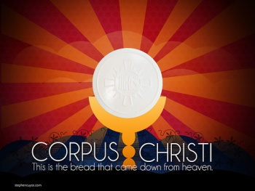

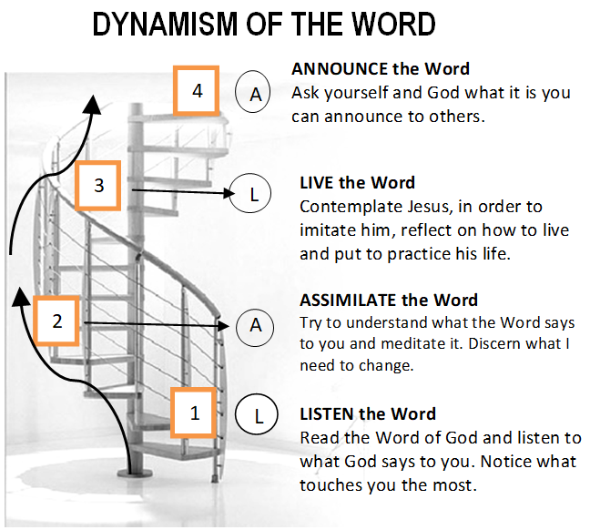

GUIDELINES FOR PRAYER

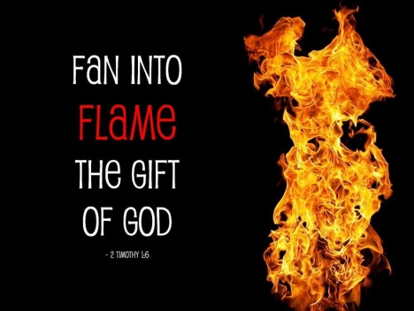

12-18 June, 2017

General Theme:
Jesus himself drew near and walked along with them.” (Lk.24:15)

General Objective:
To teach the apostles to accompany the new people with their life and their words based on how Jesus accompanied His apostles after the resurrection.

Objectives of the week:

To deepen the importance of transmitting the Spirit in our mission

