**INTRODUCTION**

As we prepare for the celebration of Pentecost, the coming of the Holy Spirit, may we as one family in Christ, continue to be nurtured by God’s Word, and constantly bear witness to a life lead by the Spirit to its fullness.

For Jesus said in John 3:5-6, “Truly, I say to you: No one can enter the kingdom of God without being born of water and Spirit. What is born of the flesh is flesh, and what is born of the Spirit is spirit”. To be born with water is to be baptized as a Christian and through the Spirit we are given the same identity with Christ: to be God’s ambassadors to His people -ambassadors led by the Spirit of peace and truth giving light and life, bringing reconciliation to the world.

Our baptism has changed us, given us a new and glorious hope, and empowered us to bring God’s redeeming love to all, particularly the poor, in whom we see the face of Christ. Thus, all of the baptized must announce Jesus with our life, with our witness and with our words.” - Pope Francis

Though, all of us experience moments of fatigue and discouragement, especially when our prayers seem ineffective (cf.Pope Francis), let us allow the Spirit to speak to us in prayer, that it may give us the strongest motivation to live out and bring the life to others through the Word of God.

A life guided by the Spirit is a life lived in freedom and not bounded by the limitations of this world. Often the risks that we take in the light of the Spirit does not conformed to what is presented to us in many situations where we are challenged to grow and understand how Jesus desires for us to do. Like St. Paul and those who have gone ahead of us, let us live the new life in Spirit even in chains. He is with us always !

**MONDAY**

**“Be an ambassador of Christ’s peace”**

All this is the work of God, who, in Christ, reconciled us to himself, and who entrusted to us the ministry of reconciliation. Because, in Christ, God reconciled the world with himself, no longer taking into account their trespasses, and entrusting to us the message of reconciliation. So we present ourselves as ambassadors, in the name of Christ, as if God, himself, makes an appeal to you, through us. Let God reconcile you; this, we ask you, in the name of Christ.

(**2 Corinthians 5:18-20)**

*Jesus is God’s ambassador of peace to His people and as often as we encounter Him, He constantly offers us this peace. In so many realities that we encounter every day, let us look and see how our presence allows Jesus’ peace to be given in every moment the Spirit provokes us. Jesus, as the Prince of Peace, desires for us to restore friendly relations with our brothers and sisters.*

*“God wants to turn your hands, my hands, our hands, into signs of reconciliation, of communion, of creation. The Lord is knocking at the door of our hearts. Have we put a sign on the door saying ‘Do not disturb’?”-***Pope Francis**

**TUESDAY**

St. Joan of Arc

**“Selflessness in Doing the Mission”**

When they came to him, he addressed them, “You know how I lived among you, from the first day I set foot in the province of Asia; 19 how I served the Lord in humility, through the sorrows and trials that the Jews caused me. 20 You know, that I never held back from doing anything that could be useful for you; I spoke publicly and in your homes; and I urged Jews, and non-Jews, alike, to turn to God and believe in our Lord Jesus. But now, I am going to Jerusalem, chained by the Spirit, without knowing what will happen to me there. Yet, in every city, the Holy Spirit warns me, that imprisonment and troubles await me. Indeed, I put no value on my life; if only I can finish my race; and complete the service to which I have been assigned by the Lord Jesus, to announce the good news of God’s grace.

**(Acts 20:18-24)**

*As Christ’s ambassadors, may we learn to do as He has done. Let us learn to be selfless in doing the mission. Fulfilling it becomes easier when our will to please God prevails over our will to please ourselves. As Christ’s disciples, to what extent do we allow the holy Spirit to guide and lead us through the way we are walking with the people we are accompanying?*

**WEDNESDAY**

Feast of the Visitation of the Blessed Virgin Mary

“**Place your Faith in the**

**Light of the Spirit”**

41 When Elizabeth heard Mary’s greeting, the baby leapt in her womb. Elizabeth was filled with the Holy Spirit, and, giving a loud cry, said, “You are most blessed among women; and blessed is the fruit of your womb! How is it, that the mother of my Lord comes to me?The moment your greeting sounded in my ears, the baby within me suddenly leapt for joy. Blessed are you, who believed that the Lord’s word would come true!” And Mary said, “My soul proclaims the greatness of the Lord, my spirit exults in God, my savior!

**(Luke 1:45-56)**

*Mary, as Jesus’ mother, is one of the first and closest persons who accompanied Him and has shown us deep and great faith in God’s will. She has showed us, too that to be Christ’s ambassador, is to be a person of humility and charity. Looking at Mary and how her “Yes” has brought life to a Son who gave His life for many, let us also examine ourselves as disciples and apostles. How much of our faith do we put in trust and confidence to where the Holy Spirit leads us, to what He asks of us to do, think, and speak?*

**THURSDAY**

St. Justin, Martyr

**“Live Life in the Spirit”**

16 Therefore, I say to you: walk according to the Spirit and do not give way to the desires of the flesh! 17 For the desires of the flesh war against the Spirit, and the desires of the Spirit are opposed to the flesh. Both are in conflict with each other, so that you cannot do everything you would like. 18 But when you are led by the Spirit you are not under the law. You know what comes from the flesh: fornication, impurity and shamelessness, idol worship and sorcery, hatred, jealousy and violence, anger, ambition, division, factions, and envy, drunkenness, orgies and the like. I again say to you what I have already said: those who do these things shall not inherit the kingdom of God.But the fruit of the Spirit is charity, joy and peace, patience, understanding of others, kindness and fidelity, gentleness and self-control. For such things there is no law or punishment. Those who belong to Christ have crucified the flesh with its vices and desires. If we live by the Spirit, let us live in a spiritual way.

**Galatians 5:16-25**

*"To obey the commandments of our Saviour* [*Jesus*](http://www.catholic.org/clife/jesus)[*Christ*](http://www.catholic.org/clife/jesus) *is worthy neither of blame nor of condemnation." -* **St. Justin, Martyr**

*As ambassadors, do we realize our mission as the carriers of His message? Let us take the step to share and help other people understand His words and witness how His words have truly worked in our lives.*

*Saint Justin Martyr, we pray that in our search for the Truth,* [*God*](http://www.catholic.org/encyclopedia/view.php?id=5217)[*will*](http://www.catholic.org/encyclopedia/view.php?id=12332) *open the gates of light for us the way* [*God*](http://www.catholic.org/encyclopedia/view.php?id=5217) *did for you and give us the* [*wisdom*](http://www.catholic.org/bible/book.php?id=27) *no human being can give.* [*Amen*](http://www.catholic.org/encyclopedia/view.php?id=644)

**FRIDAY**

St. Marcellinus and Peter

**“Speak in the Light of the Spirit”**

25 He said to them, “How dull you are, how slow of understanding! Is the message of the prophets too difficult for you to understand? Is it not written that the Christ should suffer all this, and then enter his glory?” Then starting with Moses, and going through the prophets, he explained to them everything in the Scriptures concerning himself.

**Luke 24:25-27**

Pray, at all times, as the Spirit inspires you. Keep watch, together with sustained prayer and supplication for all the holy ones. 19 Pray, also, for me, so that when I speak, I may be given words, to proclaim bravely, the mystery of the gospel. 20 Even when in chains, I am an ambassador of God; may he give me the strength to speak as I should.

**Ephesians 6:18-20**

*"I love my chains and prison too dearly, to pray to God to set me free. If you, however, promise to believe in Christ, the Son of the living God, I assure you that He will soon free me from my fetters and my prison."* **-**

**St.Peter**

*It is a challenge for us as disciples to be sent as ambassadors of Christ to accompany people- especially those who don’t recognize Him and help them understand and live His words. Despite these, let us remain faithful in prayer and be courageous that even if we’re bound in the chains of this world, may we be able to take the step in doing the mission for Him.*

*We have a Lord who is capable of crying with us, capable of walking with us in the most difficult moments of life* **-Pope Francis**

**SATURDAY**

St. Charles Lwanga and Companions

**“Be the Word in Body and Spirit”**

Keep watch over yourselves, and over the whole flock the Holy Spirit has placed into your care. Shepherd the Church of the Lord that he has won, at the price of his own blood. I know that, after I leave, ruthless wolves will come among you and not spare the flock. And, from among you, some will arise, corrupting the truth, and inducing the disciples to follow them. Be on the watch, therefore, remembering that, for three years, night and day, I did not cease to warn everyone, even with tears. Now, I commend you to God, and to his grace-filled word, which is able to make you grow and gain the inheritance that you shall share with all the saints. I have not looked for anyone’s silver, gold or clothing. 34 You, yourselves, know, that these hands of mine have provided for both my needs and the needs of those who were with me. 35 In every way, I have shown you that by working hard one must help the weak, remembering the words that the Lord Jesus himself said, ‘Happiness lies more in giving than in receiving.’” **Acts 20:28-35**

Follow the pattern of the sound doctrine which you have heard from me, concerning faith, and love in Christ Jesus.Keep this precious deposit, with the help of the Holy Spirit, who lives within us.

**2 Timothy 1:13-14**

*Pope Francis said, “It’s the duty of everyone to defend religious freedom and promote it for all people. Jesus teaches us to go out. and share your testimony. Go out and interact with your brothers , go out and share, go out and ask. Become the Word in body as well as spirit.”*

*St. Charles Lwanga and companions, martyrs of Uganda, pray for the* [*faith*](http://www.catholic.org/encyclopedia/view.php?id=4554) *where it is in danger and for Christians who suffer because of their faith. Give them the same courage, zeal, and joy you showed. Help us who live in places where* [*Christianity*](http://www.catholic.org/encyclopedia/view.php?id=2927) *is accepted to remain aware of the* [*persecution*](http://www.catholic.org/encyclopedia/view.php?id=9187) *in other parts of the world.* [*Amen*](http://www.catholic.org/encyclopedia/view.php?id=644)

**SUNDAY**

**Vigil of Pentecost**

**1st Reading** – Genesis 11:1-9 or

Exodus 19:3-8, 16-20 or Ezekiel

37:1-14 or Joel 3:1-5

**Responsorial Psalm** – Psalm 104

**2nd Reading** – Romans 8:22-27

**Gospel** – John 7:37-39

**Pentecost Sunday**

**1st Reading** – Acts 2:1-11

**Responsorial Psalm** – Psalm 104

**2nd Reading** – 1 Corinthians 12:3-7 or

Romans 8:8-17

**Gospel** – John 20:19-23 or

John 14:15-16, 23-26

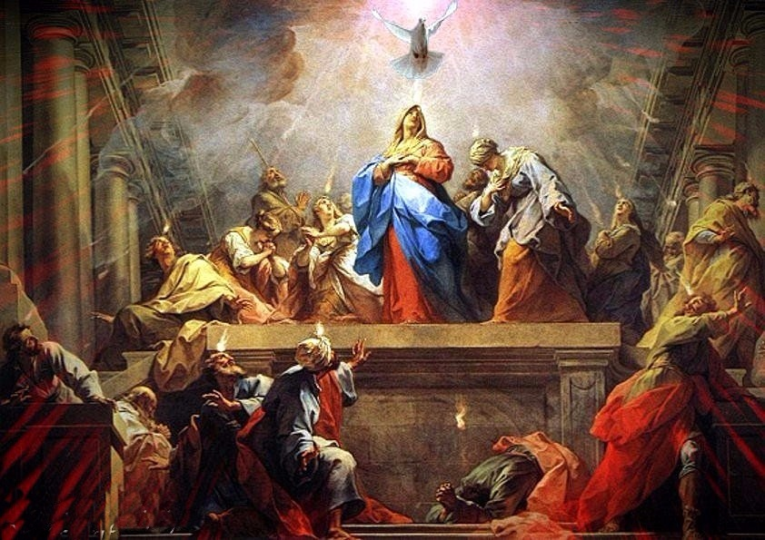



**GUIDELINES FOR PRAYER**



***“While they were still speaking…***

***He stood in their midst”***



May 29- June 4, 2017

**General Theme:**

 Jesus himself drew near and walked along with them.” (Lk.24:15)

**General Objective:**

To teach the apostles to accompany the new people with their life and their words based on how Jesus accompanied His apostles after the resurrection.

**Objectives of the week:**

- to understand what it means to live as ambassadors of Christ.

- to live being led by the Spirit.