INTRODUCTION

Last week, we deepened on how our constant dialogue with Jesus, our prayer, brings us to this constant connection with His Body. The transfiguration of Jesus brought hope in our hearts that in his death, we die with him in our sins and we who are living members of his body wait with patient hope for his resurrection.

In our journey this Lent, the image of the Pieta makes it visible Mary carrying Christ’s body with attentive gaze, gentleness, accompanying and waiting for his full resurrection in all the members. Her attentive gaze on our own lives encourages us to choose the paths of communion, love, and trust, to reject evil and sin. Mother Mary helps us in this process of inner transformation in us and in those God entrusts us. She helps us to live in faith—not being conditioned by our own vulnerabilities, and to strive always to be living members in his body; to care after Christ’s body, like her and with her same gentleness, attentive gaze, faith in God and in others.

Praying the rosary helps us to fix our eyes on Jesus through Mother Mary, in bearing in our hearts her same attentive gaze and sensitivity, seeing and understanding the situations of our brothers and sisters. Prayer as one of the most urgent means and strongest reasons for our preaching transforms us to give genuine acts of goodness, though in little ways, that can heal the Body of Christ.

Our Lady of Fatima, in her third apparition said: "Make everything you do a sacrifice, and offer it to God as an act of reparation for the sins by which He is offended, and in supplication for the conversion of sinners."

Mother Mary's attentive gaze to the body of Christ helps us to also see the reparatory value of our acts of humility and contrition in our daily ordinary way of life.
As we continue to live out our prayer, fasting, and almsgiving in this season of Lent, let us also ask Mother Mary to help us to see how we too can accompany each member of Christ's body in leading them to be constantly connected with the source. How does the means that the Church gives nourish us to become active and alive members of the Body of Christ?

MONDAY
“Look at your mother”

John 19:25-27 Now there stood by the cross of Jesus his mother, and his mother's sister, Mary the wife of Cleophas, and Mary Magdalene.When Jesus therefore saw his mother, and the disciple standing by, whom he loved, he said unto his mother, Woman, behold thy son! Then said he to the disciple, Behold thy mother! And from that hour that disciple took her unto his own home.

Jesus' last words ask from his mother was to look at his beloved disciple as her own son. In our life, in our journey as disciples of Jesus, we become fearful of losing sight of Jesus. But let us always remember that we are not moving forward alone. Mother Mary, though silent, is there watching us, walking with us, and guiding us closer to Jesus. How attentive are we to our Mother, whom Jesus has entrusted to us? How does Mother Mary's presence in my life make me see the reality of my brothers and sisters in Christ?

TUESDAY
“The reality is Christ”

Phil 3:10-12 I want to know Christ and the power of his resurrection and the sharing of his sufferings by becoming like him in his death, If somehow I may attain the resurrection from the dead. Not that I have already obtained this or have already reached the goal; but I press on to make it my own, because Christ Jesus has made me his own.’

Romans 12:3-8 For by the grace given to me I tell everyone among you not to think of himself more highly than one ought to think, but to think soberly, each according to the measure of faith that God has apportioned. For as in one body we have many parts, and all the parts do not have the same function, so we, though many, are one body in Christ and individually parts of one another. Since we have gifts that differ according to the grace given to us, let us exercise them: if prophecy, in proportion to the faith; if ministry, in ministering; if one is a teacher, in teaching; if one exhorts, in exhortation; if one contributes, in generosity; if one is over others, with diligence; if one does acts of mercy, with cheerfulness.

Jesus claimed each of us—with all our being—as his own. Entrusting us to his mother that we may be brothers and sisters united as well in one Father in heaven. Am I aware of my state as a member of the Body of Christ? Which part am I giving my active participation in the Total Christ of today?

WEDNESDAY
“Be a living sacrifice”

Psalm 51:18-19 For you do not desire sacrifice, or I would give it; a burnt offering you would not accept. My sacrifice, O God, is a contrite spirit; a contrite, humbled heart, O God, you will not scorn.

Romans12:1-2 I urge you therefore, brothers, by the mercies of God, to offer your bodies as a living sacrifice, holy and pleasing to God, your spiritual worship. Do not conform yourselves to this age, but be transformed by the renewal of your mind, that you may discern what is the will of God, what is good and pleasing and perfect.

Mother Mary always shows us the value of humility and total loving Yes, surrender and trust in God's will. As a mother to us, she too desires to lead us to the fullness of our lives connected with Christ. She is attentive to the desires of our heart and to the will of the Father. How does her attentive gaze help me to see the reality of each member of Christ's body today? How am I living out my connection with Christ?

THURSDAY
“Do whatever he tells you”

John 2:1-5 On the third day there was a wedding in Cana in Galilee, and the mother of Jesus was there. Jesus and his disciples were also invited to the wedding. When the wine ran short, the mother of Jesus said to him, “They have no wine.” [And] Jesus said to her, “Woman, how does your concern affect me? My hour has not yet come.” His mother said to the servers, “Do whatever he tells you.”

Our mother is also attentive to our needs and at the same time encourages us to be sensitive to the needs of others. She intercedes for us to Jesus and the Father. How do we allow our Mother Mary to accompany us as well in our own home or in our workplace?

FRIDAY
“Passion, sincerity, and love”

Psalm 51:3-9 ³ Have mercy on me, God, in accord with your merciful love; in your abundant compassion blot out my transgressions. Thoroughly wash away my guilt; and from my sin cleanse me. For I know my transgressions; my sin is always before me. Against you, you alone have I sinned; I have done what is evil in your eyes so that you are just in your word, and without reproach in your judgment. Behold, I was born in guilt, in sin my mother conceived me. Behold, you desire true sincerity; and secretly you teach me wisdom. Cleanse me with hyssop, that I may be pure; wash me, and I will be whiter than snow.

Nothing is hidden from the sight of God. This is why Jesus teaches us the way to be authentic bearers of life lived in union with the Father through his Mystical Body. How am I living my life in purity, truth, and love as part of Christ's body? Am I humble, contrite, and sincere toward him and to the members of his body?

SATURDAY
“Remain in me“

John 15:5-9 I am the vine, you are the branches. Those who abide in me and I in them bear much fruit, because apart from me you can do nothing. Whoever does not abide in me is thrown away like a branch and withers; such branches are gathered, thrown into the fire, and burned. If you abide in me, and my words abide in you, ask for whatever you wish, and it will be done for you. My Father is glorified by this, that you bear much fruit and become my disciples. As the Father has loved me, so I have loved you; abide in my love.’

Our constant dialogue with Jesus through prayer helps us to remain connected to the source of all things. It helps us find meaning in the midst of our difficulties and consolation even in the little that we wholeheartedly give for others. Do we imagine how our life would be apart from Jesus? How are we allowing ourselves to be bridges connecting others to the same source of life?

SUNDAY
3rd Sunday of Lent

1st Reading: Exodus 20:1-17 or 20:1-3, 7-8, 12-17
Responsorial Psalm: Psalm 19
2nd Reading: Corinthians 1:22-25
Gospel: John 2:13-25
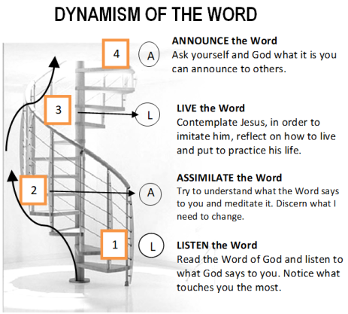

GUIDELINES FOR PRAYER

“The attentive gaze of Mary…”
February 26-March 4, 2018

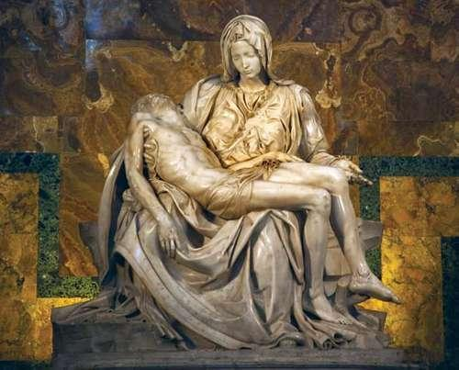
Specific Objective:
The attentive gaze of Mary upon our lives helps us to journey believing and waiting in hope for the resurrection of the crucified body of Christ.

