INTRODUCTION

Jesus in the Eucharist has become for us a spiritual source of life—a river of life giving water flowing to nourish all that comes to Him and be quenched by Him.

We will now deepen on the Eucharist as a source of spiritual nourishment for us to grow in a deeper relationship with God. Jesus’ question,“Have you anything here to eat?” in Luke 24:41 helps us to recognize how he presents himself as the first who is in need of something to eat. Jesus doesn't hide his need of “food”What is it that we can offer to him?

Oftentimes ,as disciples, we think of what we need to receive in our following, and as apostles, we focus so much on how much we give to others in the mission. But isn't it that for us to give we need to receive first? And for us to receive, we need to be more open and make some space for what we will be receiving?

Jesus in the Eucharist continues to invite us to receive him— His body and blood, as our spiritual nourishment. He is the first one who comes to us in need of our life. The Body of Christ in our different realities, our family, colleagues, and co-disciples hunger for our presence, time, sincerity, truthfulness, humility, love, and selflessness.
"The Holy Eucharist signifies and achieves the union of all people as One. Its very fruit is communion. It is the sacrament and sacrifice that is fundamentally constitutive of Christian fraternity. Nourished by the Eucharistic bread, the apostle becomes a brother and sister to all people, thereby creating universal fraternity." VDC73

He needs from us our humility, openness, and willingness to receive—for him to fill us, our hearts, and our minds with the food that truly gives life.

MONDAY
Here's my heart!

Proverbs 4:23
With all vigilance guard your heart, for in it are the sources of life.

He is concerned of the things that we fill in our hearts knowing its capacity to carry life and give life to our body. Indeed food is in the heart of Jesus that he desires to be that food that nourish us and give us life.

When I hunger for the things of this world, what kind of food do I fill my heart with? What do I keep in my heart?

Jesus in the Eucharist offers himself as food that can fill the hunger and nourish our heart.

Knowing that Jesus himself within our hearts becomes the source of life, do I allow Jesus to fill up my heart?

TUESDAY
Here's my mind!

Romans 12:1-2
I urge you therefore, brothers, by the mercies of God, to offer your bodies as a living sacrifice, holy and pleasing to God, your spiritual worship. Do not conform yourselves to this age but be transformed by the renewal of your mind, that you may discern what is the will of God, what is good and pleasing and perfect.

Our growth as disciples involves the continuous renewal of our minds. The way we see, we think, we speak, and we move is gradually transformed by the spiritual food we receive in the Eucharist.

Do I allow my mind to be transformed by Jesus in the Eucharist? How am I receiving his Words and allowing it to change the way I think and live?

WEDNESDAY
Here's my will!

Matthew 26:36-46
Then Jesus came with them to a place called Gethsemane, and he said to his disciples, “Sit here while I go over there and pray.” He took along Peter and the two sons of Zebedee, and began to feel sorrow and distress. Then he said to them, “My soul is sorrowful even to death. Remain here and keep watch with me.” He advanced a little and fell prostrate in prayer, saying, “My Father, if it is possible, let this cup pass from me; yet, not as I will, but as you will.” When he returned to his disciples he found them asleep. He said to Peter, “So you could not keep watch with me for one hour? Watch and pray that you may not undergo the test. The spirit is willing, but the flesh is weak.” Withdrawing a second time, he prayed again, “My Father, if it is not possible that this cup pass without my drinking it, your will be done!” Then he returned once more and found them asleep, for they could not keep their eyes open. He left them and withdrew again and prayed a third time, saying the same thing again. Then he returned to his disciples and said to them, “Are you still sleeping and taking your rest? Behold, the hour is at hand when the Son of Man is to be handed over to sinners. Get up, let us go. Look, my betrayer is at hand.”

How does my will drive my life? Am I aware that God, who gave life to my body, also has a plan for my life?

In my following as a disciple through the Eucharist, praying with the Word of God, preaching and witnessing it in my life, do I seek to eat, drink, and be nourished myself according to the purpose that God willed for me to grow and live?

THURSDAY
Here are my sins!

Hebrews 5:1-3
Every high priest is taken from among men and made their representative before God, to offer gifts and sacrifices for sins. He is able to deal patiently with the ignorant and erring, for he himself is beset by weakness and so, for this reason, must make sin offerings for himself as well as for the people.

Jesus embraces us in our sinfulness, continuing to provide us the food that is lasting and true; food that can nourish and strengthen us to live a life pleasing to Him.

Am I willing to let go all the temporary things in my heart and mind in exchange for the lasting food that Jesus is providing me in the Eucharist?

How can I prepare myself to be able to receive more of what Jesus is giving in the Eucharist, for me and for the people I accompany every day?

FRIDAY
Here are my talents!

Matthew 25;14-30
“It will be as when a man who was going on a journey called in his servants and entrusted his possessions to them. To one he gave five talents; to another, two; to a third, one—to each according to his ability. Then he went away. Immediately the one who received five talents went and traded with them, and made another five. Likewise, the one who received two made another two. But the man who received one went off and dug a hole in the ground and buried his master’s money. After a long time the master of those servants came back and settled accounts with them. The one who had received five talents came forward bringing the additional five. He said, ‘Master, you gave me five talents. See, I have made five more.’ His master said to him, ‘Well done, my good and faithful servant. Since you were faithful in small matters, I will give you great responsibilities. Come, share your master’s joy.’ [Then] the one who had received two talents also came forward and said, ‘Master, you gave me two talents. See, I have made two more.’ His master said to him, ‘Well done, my good and faithful servant. Since you were faithful in small matters, I will give you great responsibilities. Come, share your master’s joy.’ Then the one who had received the one talent came forward and said, ‘Master, I knew you were a demanding person, harvesting where you did not plant and gathering where you did not scatter; so out of fear I went off and buried your talent in the ground. Here it is back.’ His master said to him in reply, ‘You wicked, lazy servant! So you knew that I harvest where I did not plant and gather where I did not scatter? Should you not then have put my money in the bank so that I could have got it back with interest on my return? Now then! Take the talent from him and give it to the one with ten. For to everyone who has, more will be given, and he will grow rich; but from the one who has not, even what he has will be taken away. And throw this useless servant into the darkness outside, where there will be wailing and grinding of teeth.’

What do we have that we can consider as truly belonging to us? All that we are and have comes from Him. He entrusted them all to us for others.

Do we come to Jesus in the Eucharist with an open heart and free will to offer what we have? In what way does Jesus invite you to take care and invest what you have received from him?

SATURDAY
Here's my life!

John 10:17-18
This is why the Father loves me, because I lay down my life in order to take it up again. No one takes it from me, but I lay it down on my own. I have power to lay it down, and power to take it up again. This command I have received from my Father.”

Lord, how can I repay you after all the goodness you’ve shown to me?
You freely and willingly offered your life as food to give nourishment to all who receives you.

How much of my life do I offer you, Jesus? Am I doing it for myself alone or for others as well?

SUNDAY
Tenth Sunday in Ordinary Time

1st Reading – Genesis 3:9-15
Responsorial Psalm – Psalm 130
2nd Reading – 2 Cor 4:13-5:1
Gospel – Mark 3:20-35

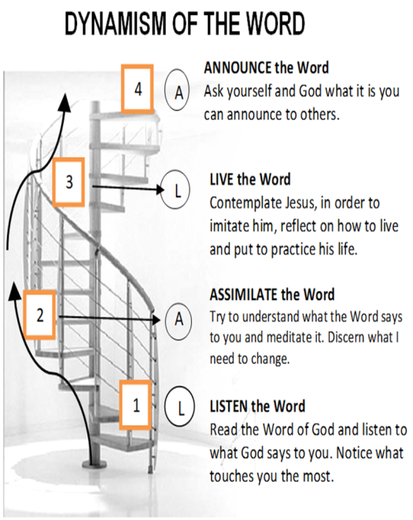

Guidelines for Prayer

“Have you anything here to eat?”

(Luke 24:35-48)

June 4-10, 2018

General Objective:
To be nourished by the Eucharist;
To grow in relationship with Jesus in the Eucharist
Objective of the week:
To recognize how Jesus presents himself as the first one who needed something to eat.

