INTRODUCTION
For this week we are invited to strengthen our identity as an apostle chosen and called by God. What can an apostle be? An image of an apostle is “a co-worker of God” (1 Cor 3:9). What He is forming in us is an apostle who is free. Nobody makes himself an apostle, an official witness to Christ. One has to be called to this responsibility. An apostle is a committed Christian who shares the life-style and human aspirations of their companions in everything that is not sinful. An apostle is called to be a gift for others; God’s choice and not on anything they had done (cf. Rom. 9:12b). “I invite all Christians, everywhere, at this very moment, to a renewed personal encounter with Jesus Christ, or at least an openness to letting them encounter Him; I ask all of you to do this unfailingly each day. No one should think, that this invitation is not meant for him or her, since, “no one is excluded from the joy brought by the Lord” (Pope Francis).
MONDAY
A servant not greater than his master

(Feast of the Guardian Angels)

Jn 13:16-17 Truly, I say to you, the servant is not greater than his master, nor is the messenger greater than he who sent him. Understand this and blessed are you if you put it into practice.
Eph 3:7-9 I was made a servant of the gospel by God’s special gift, which he gave me through the working of his power. I am less than the least of all God’s people; yet God gave me this privilege of taking to the Gentiles the Good News about the infinite riches of Christ and of making all people see how God’s secret plan is to be put into effect.
As an apostle of Christ, one becomes a servant of all yet enjoys the bountiful richness of Christ’s divinity that He shared. As an apostle of Christ, we are to take the first step in humility and mercy, in order to help purify others who approach the Lord. Let us strive learning to be child-like today. This will lead us in letting God be God, letting others be others, and ourselves as ourselves.
Am I ready to serve when asked to serve?
TUESDAY
Taking the same path of Jesus

(St. Theophilus)

Lk 9:51-56 As the time drew near when Jesus would be taken up to heaven, he made up his mind to go to Jerusalem. He sent ahead of him some messengers who entered a Samaritan village to prepare a lodging for him. But the people would not receive him because he was on his way to Jerusalem. Seeing this, James and John, his disciples said, “Lord, do you want us to call down fire from heaven to reduce them to ashes?” Jesus turned and rebuked them, and they went on to another village.
As an apostle, we are called to forgive when hurt, to embrace others when turned away, to love without limits when hated, to be strong when put to trials and temptations, to be in control of ourselves like Jesus, and to be less impulsive when angry. Be willing to follow Jesus’ path where He is leading you to.
Am I willing to follow the path that Jesus went through? Do I recognize the truth and life of this journey?
WEDNESDAY
A bringer of peace

(St. Francis of Assisi)

Lk 10:1, 5 After this the Lord appointed seventy-two other disciples and sent them two by two ahead of him to every town and place, where he himself was to go. “Whatever house you enter, first bless them saying: Peace to his house.”
As bringer of peace, an apostle is to come as a friend on behalf of Christ and his Church. To be reconciled with family members and neighbors, and to let go of resentments. Begin doing what you can do, and trust that, in His own way, God will solve what is beyond your own power. This peace is preserved by listening to God who alone gives peace.
Am I ready to bring peace that comes not from my own effort but from God’s grace?
THURSDAY
A messenger bringing the Good News

(St. Faustina Kowalska)

Rom 10:15 And how will they preach about him if no one sends them? As Scripture says: How beautiful are the feet of the messenger of good news.
An apostle is willing to be in a mission that helps him form himself as an apostle. He awakens those that they visit. The best apostle for missionary work are often those who have been and has been continually transformed by Christ, living his life that conforms to what Jesus taught and lived. Let us be joyful and full of conviction in collaborating with Jesus’ mission of bringing the good news and reaching to as many of our brothers and sisters as possible.
Am I willing to bring Jesus and proclaim the good news to others? Who are the concrete person(s) or place(s) that God is wanting you to proclaim and share the good news?
FRIDAY
Called to make a difference like Jesus

(St. Bruno)

Mt 11:20 Then, Jesus began to denounce the cities, in which he had performed most of his miracles, because the people there did not change their ways.
2 Cor 6:14-15 Do not make unsuitable covenants with those who do not believe: can justice walk with wickedness? Or can light coexist with darkness, and can there be harmony between Christ and Satan? What union can there be between one who believes and one who does not believe? God’s temple must have no room for idols, and we are the temple of the living God. As Scripture says: I will dwell and live in their midst, I will be their God and they shall be my people.
As apostles of Christ, we are invited to embrace and pray for the unbelievers of this world, yet we are called to make a concrete options to go against the world and its sinful ways and try with all our strength to stay faithful with it. Let our lives, though not perfect, be pleasing to God alone for we are His temple.
What change(s) does the Lord invites me to live?
SATURDAY
Sharing the joy of being called and chosen like Mary

(Our Lady of the Rosary)

Lk 10:21-24 At that time Jesus was filled with the joy of the Holy Spirit and said, ”I praise you, Father, Lord of heaven and earth, for you have hidden these things from the wise and learned, and made them known to little ones. Yes, Father, such has been your gracious will. I have been given all things by my Father, such has been your gracious will. I have been given all things by my Father, so that no one knows the Son except the Father and no one knows the Father except the Son and he to whom the Son chooses to reveal him.” Then Jesus, turned to his disciples and said to them privately, “Fortunate are you to see what you see, for I tell you that many prophets and kings would have liked to see what you see but did not see it, and to hear what you hear but did not hear it.”
Lk 1: 41-45 When Elizabeth heard Mary’s greeting, the baby leapt in her womb, Elizabeth was filled with Holy Spirit, and giving a loud cry, said, “You are most blessed among women and blessed is the fruit of your womb! How is it that the mother of my Lord comes to me? The moment your greeting sounded in my ears, the baby within me suddenly leapt for joy. Blessed are you who believed that the Lord’s word would come true!”
Like Mother Mary, she kept on accepting the challenges of being chosen with all the pondering and discerning with total obedience, joyful heart, and faithfulness to what God is telling her. We too ought to share the joy of being an apostle in humility and gratefulness to the One who chooses and gives us such gift and privilege.
Do I savor and share the joy I have as His apostles?

SUNDAY
27th Sunday in Ordinary Time
(Indigenous People’s Sunday)
First Reading: Is. 5:1-7
Psalm: Ps 80:9, 12-16, 19-2
Second Reading: Phil 4:6-9
Gospel: Matthew 21:33-43

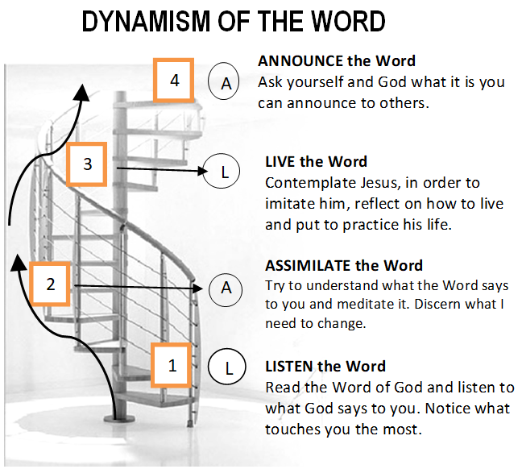

GUIDELINES FOR PRAYER
“I AM AN APOSTLE” (1Cor9:1)

October 2-8, 2017

General Theme:
“You are an apostle, chosen and called (cf. Rom. 1:1)”

General Objective:
To deepen and strengthen the identity of being an apostle today

Objective of the week:
To strengthen the identity of being an apostle chosen and called by God.

Page 1 of 3
Guidelines Sheet for Prayer

