INTRODUCTION
In the past weeks we were invited to learn to see Jesus as a formator and understand how He is teaching us to live our lives forming our brothers and sisters in Christ as well. With this, it is necessary that we find in every moment of our life as disciples the process of understanding what, why, and what for are these things that Jesus is teaching us. Our master’s itinerary for us is to do as He has done--to form others as He has formed us.

In order to deepen in the itinerary that Jesus made in His apostles, we must also have a deeper understanding of how He taught and moved his disciples to live more than just receiving--understanding that what we receive is meant to be given for others, so that they too may grow in faith, so that through their faith, they too may bear fruit for those who also hunger and thirst in the body of Christ.

This week, as disciples, let us also see how Jesus is working how JESUS is working in us, preparing us and sending us as apost sending us to the different realities of His
Church.

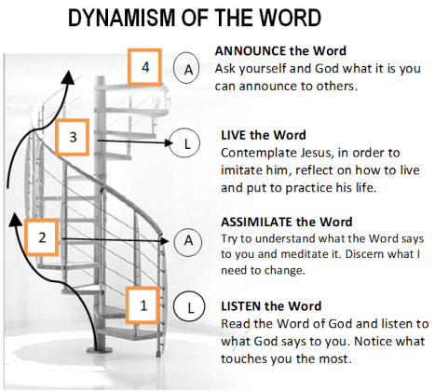

MONDAY
“Trust in Him who sent me”

Luke 11:1-13 ¹ One day, Jesus was praying in a certain place; and when he had ﬁnished, one of his disciples said to him, “Lord, teach us to pray, as John also taught his disciples.” ²And Jesus said to them, “When you pray, say this: Father, may your name be held holy, may your kingdom come; ³ give us, each day, the kind of bread we need, ⁴ and forgive us our sins; for we also forgive all who do us wrong; and do not bring us to the test.” ⁵ Jesus said to them, “Suppose one of you has a friend, and goes to his house in the middle of the night and says, ‘Friend, lend me three loaves, ⁶ for a friend of mine who is traveling has just arrived, and I have nothing to offer him.’ ⁷ Maybe your friend will answer from inside, ‘Don’t bother me now; the door is locked, and my children and I are in bed, so I can’t get up and give you anything.’ ⁸ But I tell you, even though he will not get up and attend to you because you are a friend, yet he will get up because you are a bother to him, and he will give you all you need. ⁹ And so I say to you, ‘Ask, and it will be given to you; seek, and you will ﬁnd; knock, and it will be opened to you. ¹⁰ For the one who asks receives, and the one who searches ﬁnds, and to him who knocks the door will be opened. ¹¹ If your child asks for a ﬁsh, will you give him a snake instead? ¹² And if your child asks for an egg, will you give him a scorpion? ¹³ If you sinful people know how to give good gifts to your children, how much more will your heavenly Father give the Holy Spirit to those who ask him.”

Matthew 17:20 “If you have faith as grain of mustard seed, you will say to this mountain, “MOVE!” and it will move, and nothing will be impossible for you.”

Jesus taught his apostles that prayer is a relationship with the father. His disciples are the direct witnesses to this act of faithfulness of Jesus. He taught us to pray to the Father (v.2) for he knows that the graces we need for the mission can only be given to us by our Father if we have the confidence and trust in his will for us.

Do we trust and ask our Father in heaven, with sincerity and humility, for the graces we need for the mission?
TUESDAY
“Courage! I am sending you”

Matthew 5:17 Do not think that I have come to annul the law and the prophets. I have not come to annul them, but to fulﬁll them.

Luke 10:1-3 ¹After this, the Lord appointed seventy-two other disciples, and sent them, two by two, ahead of him, to every town and place, where he himself was to go. ² And he said to them, “The harvest is plentiful, but the workers are few. So you must ask the Lord of the harvest to send workers to his harvest. ³ Courage! I am sending you like lambs among wolves.

Jesus teaches us to learn from other people who have lived before us, in the way they live the struggles they had and how they’ve lived with faith. We are born into the world and cannot be apart from it for the Father sent us to the world, just as he sent His only begotten Son. To see them the way the Father looks at them is a way for us to learn from them, and find out the truths that Jesus is teaching us in the midst of the reality we are living now.

How keen are we to distinguish with eyes of faith, the right or wrong in the ideas and things that the world of today present to us?
WEDNESDAY
“Go, my apostles,teach them”

Luke 6:12 At this time, Jesus went out into the hills to pray, spending the whole night in prayer with God. ¹³ When day came, he called his disciples to him, and chose Twelve of them, whom he called ‘apostles’

Mark 6:6-13 Jesus then went around the villages, teaching. ⁷ He called the Twelve to him, and began to send them out two by two, giving them authority over evil spirits. ⁸ And he ordered them to take nothing for the journey, except a staff: no food, no bag, no money in their belts. ⁹ They were to wear sandals and were not to take an extra tunic. ¹⁰ And he added, “In whatever house you are welcomed, stay there until you leave the place. ¹¹ If any place doesn’t receive you, and the people refuse to listen to you, leave after shaking the dust off your feet. It will be a testimony against them.” ¹² So they set out to proclaim that this was the time to repent. ¹³ They drove out many demons and healed many sick people by anointing them.

Matthew 28:20 and teach them to observe all that I have commanded you. I am with you always, even to the end of the world.”

To become an apostle, one needs to be a disciple who is dedicated and willing to live, learn, and share their life with Jesus. Having heard of our master’s teachings, as apostles of Christ, we are given the authority and responsibility to transmit what we have learned from him: to keep and have the courage to live out what our master has taught us.

What are the things that Jesus taught us? How deep is our understanding of his teachings? How do we persevere to keep and live out his teachings in our daily life?
THURSDAY
“Blessed are you,
if you put it into practice”

Mark 9:33-37 ³³ They came to Capernaum and, once inside the house, Jesus asked them, “What were you discussing on the way?” ³⁴ But they did not answer, because they had been arguing about who was the greatest. ³⁵ Then he sat down, called the Twelve and said to them, “If someone wants to be ﬁrst, let him be last of all and servant of all.” ³⁶ Then he took a little child, placed him in their midst, and putting his arms around him he said to them,³⁷ “Whoever welcomes a child such as this in my name, welcomes me; and whoever welcomes me, welcomes not me, but the One who sent me.”

Jesus sees that it is essential to form his apostles in terms of their values, criteria, etc. that He takes every experiences in life as an apportunity for them to grow as apostles sent out for the mission.

How do we welcome Jesus’ ways of forming us as His apostles?
FRIDAY
“Do as I have done”

John 13:12-17 When Jesus had ﬁnished washing their feet, he put on his garment again, went back to the table, and said to them, “Do you understand what I have done to you? ¹³ You call me Master and Lord, and you are right, for so I am. ¹⁴ If I, then, your Lord and Master, have washed your feet, you also must wash one another’s feet. ¹⁵ I have given you an example, that as I have done, you also may do. ¹⁶ Truly, I say to you, the servant is not greater than his master, nor is the messenger greater than he who sent him. ¹⁷ Understand this, and blessed are you, if you put it into practice.

To wash one another’s feet as Jesus has done to his apostles shows humility and servanthood. Our master teaches us that, to be one in humility and love, we must serve one another in lowliness of heart and mind so that through this, we can do to others what He has done for us. The process that He is doing with us as his apostles —be in difficulties, troubles, worries, joys--every experiences lived with faith is the best guidelines to form others.

How do we see and understand with a prayerful heart the process that the Lord is working in us? In the realities that we face daily, do we find the value of what we are learning from our experiences with Jesus as a way also to form our brothers and sisters?

SATURDAY
“Take and learn from me. Be humble“

Matthew 11:27-30 Everything has been entrusted to me by my Father. No one knows the Son except the Father; and no one knows the Father except the Son, and those to whom the Son chooses to reveal him. ²⁸ Come to me, all you who are weary and burdened, and I will give you rest. ²⁹ Take my yoke upon you and learn from me, for I am gentle and humble of heart; and you will ﬁnd rest. ³⁰ For my yoke is easy; and my burden is light.”

John 15:4 Live in me as I live in you. The branch cannot bear fruit by itself, but has to remain part of the vine; so neither can you, if you don’t remain in me.

Jesus developed in them one of the most important attitude as an apostle. It is to be humble to learn from his master because without him one can’t bear fruit. In living our apostleship, in every moment that Jesus sends us to do as he has done, how do we depend on Him?
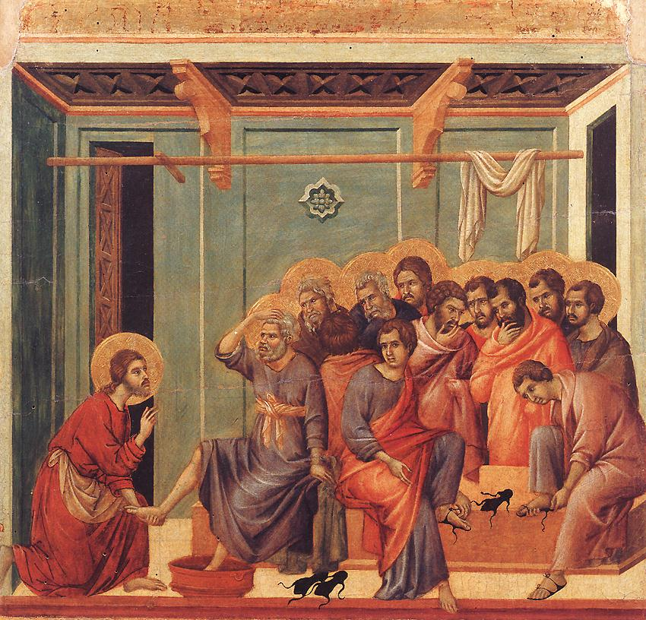
SUNDAY
Twenty-first Sunday in Ordinary Time

1st Reading: Isaiah 22:19-23
Psalm: 138:1-2, 2-3, 6, 8
2nd Reading: Romans 11:33-36
Gospel: Matthew 16:13-20

GUIDELINES FOR PRAYER

“From Disciple to

Apostle”
August 21-27, 2017

General Theme:
“Jesus sat down and taught them”

General Objective:
To deepen how to form Disciples/ Apostles of Christ and to give content in the formation of Apostles.

Objective of the week:
To learn and deepen in the itinerary that Jesus made in his apostles.

