**INTRODUCTION**

As we continue to ponder on the enlargement and expansion of our tent, the community provides us already the means on how to achieve this expansion and enlargement through the National Apostolic Project (NAP).

In this moment, we continue to see and listen through our prayer where the Lord wants for us to invest our lives. We can do this by helping in reaching the goal of the NAP through the seven priorities that our Family Verbum Dei have seen. These priorities are the directions given to us to journey together as family. As part of the family, we are co-responsible in achieving the goal of the NAP. Let us be faithful in putting our talents and capacities in applying these priorities because we were given these in the “measure of our own abilities”. The Lord does not expect us something that we cannot do. So let us put our two fish and five loaves. Let us put what we can and what we have, and allow God to multiply it.

We do all these with the concrete reason that we are capacitated because of God’s LOVE, and our LOVE to God and to his people. Let us not deprive others from knowing and hearing God through our charism just because we fear to give ourselves, fear of commitment, and fear of humiliation. Instead, let us see that through these priorities we grow, we move, we live, we discover, and we gain joy together as a family and as individual followers of Christ.

**DYNAMISM OF THE WORD**

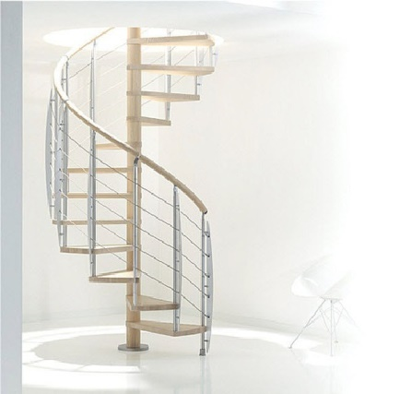



L

**MONDAY**

***INWARD GROWTH IN UNION WITH JESUS***

***(Process of Formation)***

**Luke 11:1**“Lord, teach us how to pray”

**Constitutions of the Verbum Dei Missionary Fraternity 48**

The exercise of the ministry of the Word in its diverse forms aspires to a process of drawing people to Christ, in the measure of the capacities and possibilities of each listener. It is a patient labour of teaching and learning to pray, through which the apostle takes the disciple by the hand towards the person of Christ rather than providing theoretical explanations. We have saved someone when we have taught him/her to pray. Christ will have a new disciple when s/he, through prayer, “comes to know Him” personally, not by hearsay but by personal experience. The fullness of our missionary joy will consist in this.

*Enlarging the space of our tent (our personal capacity to give of what we recognize we have) will always start from a single intention, intention to draw and be drawn to the source of wisdom, Jesus himself. Our deepest desire to be in union with Jesus measures the intensity of our commitment to follow him more closely, and be transformed in our desires, perspective in life, decisions and in the manner we live each day. Are we learning in our prayer to know ourselves better?*

**TUESDAY**

***ZEAL FOR MISSIONARY EXPANSION***

***(Missionary Expansion)***

**Romans 10:14.** “How then shall they call on him in whom they have not believed? And how shall they believe in him whom they have not heard? and how shall they hear without a preacher?”

**Constitutions of the Verbum Dei Missionary Fraternity no. 16**

Seeing the signs of the times, and sensing the urgency of our mission, we understand the importance of the charism entrusted to us by God. As apostles, we recognize that through our charism each one is entrusted with the life of God: Life which is to be transmitted to our brothers and sisters: “We will put all our efforts so that all people “reach the full knowledge of the truth” so that they may be, know and feel themselves as brothers and sisters, children of the same Father, with the same rights and duties. Our highest ideal will be to make of all nations, disciples of Jesus Christ, who may in turn proclaim with their life and word, the Good News of the Kingdom and the wonders of God”

*Jesus in his public ministry would always encourage His Apostles to Go out and spread whatever Good News they understood from HIM and when they obeyed Him they experience Joy. It never ended with the apostles. It continues to transcend to us because the Truth about Him is the same truth yesterday, today and tomorrow. What stops us from spreading the truth and Joy we receive from HIM?*

**WEDNESDAY**

***WE NEED MORE PLACES FOR PRAYER***

***(Centers of Apostolate)***

**1 Timothy 2:4.** Because God desires that all be saved and come to the knowledge of the truth**.**

**Statutes of the Verbum Dei Missionary Fraternity no. 195**

“Every center - people of God on the move, essentially missionary and open to the needs of the Church, forge and seedbed of new Christians - will be composed of a multiform structural network: a variety of spaces and buildings characteristically suitable for the contemplative-active life of the members and the different groups who come together in these centers, without any reduction in the testimony of life of extreme poverty, which is an essential part of a universal fraternity”

*Most of our personal encounter with God happens in the places where Communicating with Him is more conducive. Though we all can pray anytime, anywhere and everywhere yet there are still places that are best suited for prayer and worshiping our Creator. We can, at this time, ask the Lord to multiply these places of prayer and worship to be near and accessible to many of our brothers and sisters.*

**THURSDAY**

***SO THAT MANY WILL KNOW THE GOOD NEWS***

***(Evangelization of Society)***

**Mark 16:15** “Go into the whole world and preach the gospel to all creation”.

**Acts 3:6** Gold and silver we do not have, but we can offer them the Word of God.

**Constitutions of the Verbum Dei Missionary Fraternity no. 55**

Aiming that the Word may have an impact on the unjust structures of the world in order to transform them according to the Kingdom of God”

*Believe that we have the best offering to the world, and the world is in dire need of it. Majority of the world don’t have any idea and experience of it and yet you have it abundantly. Can you not share even a bit of it? What holds you back from giving it? Your happiness will never be complete unless you share it all.*

**FRIDAY**

***WORK FOR A COMMON CAUSE OF EVANGELIZATION***

***(Structures of Communion)***

**Christifideles laici no. 55**

“All the states of life, whether taken collectively or individually in relation to the others, are at the service of the Church's growth. While different in expression they are deeply united in the Church's "mystery of communion" and are dynamically coordinated in its unique mission. Thus in the diversity of the states of life and the variety of vocations, this same, unique mystery of the Church reveals and experiences anew the infinite richness of the mystery of Jesus Christ”

*Upon understanding from Jesus something to act upon, always consider and ask help from other disciples. As Jesus sent the 72 disciples in pairs, it will always be efficient in the presence of the faithful who is collaborating with us in the same mission and with this same cause for evangelization.*

**SATURDAY**

***PROVIDE SEVERAL INSTANCES FOR EVERYBODY TO ANSWER GOD’S CALL***

***(Vocation)***

**John 4:35.** "Look! The field is ready for the harvest"

**Lumen Gentium, Chapter 5**

Each baptized and each disciple is called to perfection in love in their state of life according to the universal call to holiness, so strongly emphasized by the Church in the Second Vatican Council.

*Even in this challenging times of our faith, still there are many people out there who desire to fully live their lives in accordance to God’s will but have not recognized it because they have not received and heard this call from the one who had created them. Let us not deprive all these people from knowing their purpose in life and the real happiness. As one family with one calling to forming apostles of Christ, it is but our responsibility to be a bridge for these vocations.*

**SUNDAY**

**8th Sunday in Ordinary Time**

**1st Reading:** Isaiah 49:14-15

**Responsorial Psalm:** Psalm 62:2-3,6-9

**2nd Reading:** 1Corinthians 4:1-5

**Gospel**: Matthew 6:24-34

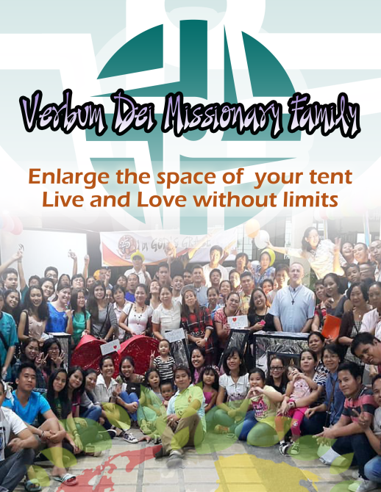



**GUIDELINES FOR PRAYER**



***“…….do not hold back!”***



February 20-26, 2017

**General Theme:** Enlarge the space of your tent. (Isaiah 54:2)

**General Objectives:**

To introduce the National Apostolic Project (NAP) to the VDMFa inviting them to own and personalize this project of God for the Verbum Dei Missionary Family Philippines for the next three (3) years.

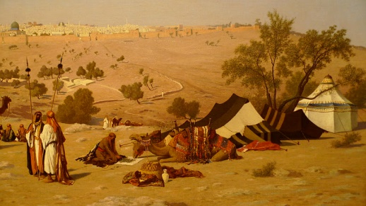



**Objective of the week:**

To heed a personal call to choose a priority you are more inclined or called to collaborate in.