**INTRODUCTION**

*My children, how hard it is to enter the kingdom of God. It is much harder for a rich man to enter the kingdom of God than for a camel to go through the eye of a needle. At this, the disciples were completely amazed and asked one another, “Who can be saved?” Jesus looked straight at them and asked, “This is impossible for human beings but not for God; everything is possible for God.* ***(Mark 10: 23-27)***

In the beginning, God has already planned that each one of us has a special place in heaven. He is our Father and we are His children, and heaven is our final destination where all are joyfully gathered in union with Him. Yet, as we look around, we can notice that many of His children choose to deviate from His plan and use up all their hours of the day for their own concerns and preoccupations. They are too busy piling up worldly things and seem to refuse God’s invitation to grow and live in the fullness in Him. Many people dream of setting up big businesses. Others look ahead to a successful career. Some do public services for fame and glory. The focus of life is no longer for God’s greater glory but toward the material possession which they have invested and sacrificed for their own comfort and convenience. All their efforts unconsciously corrupt their conscience and fall into selfishness, insensitivity and not knowing that everything will be gone and nothing will be taken after death.

Last week, we were reminded to extend our tent and make its stakes stronger to accommodate our brothers and sisters. This week is the beginning of Lent. A favorable season of welcoming our brothers and sisters, who deserve acceptance, respect, and love. It is the season where we are asked and invited to return to our God with all our hearts. (cf. Joel) Let us invite everyone to come closer to our Father in this season of Lent in an atmosphere of mercy and compassion. Let us help them feel the warm embrace of the Father who waits for them. Let us give them the awareness that they are precious and important in His sight. How can you enter the kingdom of God? Are worldly treasures helping us to possess the kingdom of God? What is necessary to attain God’s kingdom?

**DYNAMISM OF THE WORD**

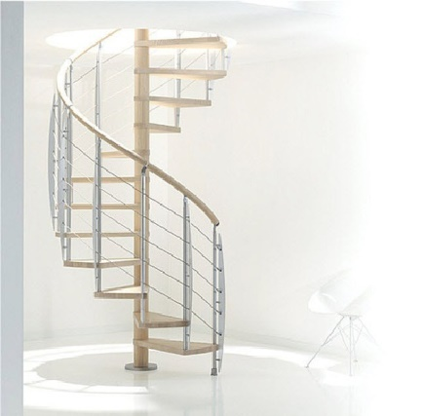



L

**MONDAY**

***THE KINGDOM OF GOD IS ABOUT LISTENING TO HIS WORD***

**Matthew 13:46**  46 when he finds one of great value he goes and sells everything he owns and buys it.

**Luke 13:22-24**  22 Through towns and villages he went teaching, making his way to Jerusalem. 23 Someone said to him, 'Sir, will there be only a few saved?' He said to them, 24 'Try your hardest to enter by the narrow door, because, I tell you, many will try to enter and will not succeed.

*Mercy and compassion is very necessary in accommodating our brothers and sisters. We can gain these virtues through constant listening to God. That is why prayer is vital in the mission for it transforms us into Christ and in the way we look at things would become similar to His. We will also become more sensitive in all our actions and decisions and most of all, we will become more vulnerable to the feelings and the needs of others. Let us continue to show our loving relationship with our God as we do our mission in helping others to seek the kingdom of God. How is your prayer life? Are you still doing it every day? How is your relationship with God? How about your neighbour?*

**TUESDAY**

***THE KINGDOM OF GOD IS ABOUT REACHING OUT TO EVERYONE***

**Matthew 10:28-29**  28 'Do not be afraid of those who kill the body but cannot kill the soul; fear him rather who can destroy both body and soul in hell. 29 Can you not buy two sparrows for a penny? And yet not one falls to the ground without your Father knowing.

**Matthew 23:37**  37 'Jerusalem, Jerusalem, you that kill the prophets and stone those who are sent to you! How often have I longed to gather your children together, as a hen gathers her chicks under her wings, and you refused!

*To follow Christ is to be free from the baggage of pride, possessions, anxieties, and the like in order to focus on the mission. We have responsibilities to bring others back to Christ. The question is who will do the mission to reach them? Our time and abilities to speak and move are instruments of showing God how much we love Him. It is also our gauge how deep is our relationship with Him. Our relationship with Him is our driving force to do the mission. Let us show compassion to them and invite them to return to Christ who is gracious and merciful. Are you ready to leave your baggage? Are you willing to collaborate with Christ?*

**WEDNESDAY**

***THE KINGDOM OF GOD IS ABOUT BRINGING OTHERS TO HIM***

**2 Corinthians 5:19**  19 I mean, God was in Christ reconciling the world to himself, not holding anyone's faults against them, but entrusting to us the message of reconciliation.

**2 Corinthians 6:2**  2 As he said, 'At the time of my favour I have answered you; on the day of salvation I have helped you'; well, now is the real time of favour, now the day of salvation is here.

*The joy of the Father overwhelms over a sinner who returns to Him. He does not only forgive sins but he also forgets sins no matter how big it is for God’s love is greater than sin. Each sinner has a special place in His heart and is deserved a chance to change. So, let us go out and tell them that they are precious and important in His sight. They don’t need to worry for God doesn’t keep records of wrong. To prepare ourselves in this Lenten season, let us try to accept, love, and value them and show them the path of conversion.*

**THURSDAY**

***THE KINGDOM OF GOD IS CULTIVATING OUR RELATIONSHIP WITH HIM***

**Matthew 25:34-36**  34 Then the King will say to those on his right hand, "Come, you whom my Father has blessed, take as your heritage the kingdom prepared for you since the foundation of the world. 35 For I was hungry and you gave me food, I was thirsty and you gave me drink, I was a stranger and you made me welcome, 36 lacking clothes and you clothed me, sick and you visited me, in prison and you came to see me."

**Luke 12:31-32**  31 No; set your hearts on his kingdom, and these other things will be given you as well. 32 'There is no need to be afraid, little flock, for it has pleased your Father to give you the kingdom.

*God is faithful to His promise of salvation. We should not be hesitant to do the mission for it is the perfection of our prayer. Let us take this as a challenge to grow into being active Christians by living out God’s word that we pray each day. It is the gauge of our identity as VD disciples. Our prayers and goodness each day are our manifestations of our intimacy with Him. By the time when the Lord calls us, He will welcome us into His heavenly kingdom.*

**FRIDAY**

***THE KINGDOM OF GOD IS BEING HUMBLE AND GRATEFUL TO HIM***

Lent is a new beginning, a path leading to the certain goal of Easter, Christ’s victory over death. This season urgently calls us to conversion. Christians are asked to return to God “with all their hearts” (Joel 2:12) to refuse to settle for mediocrity and to grow in friendship with the Lord. Jesus is the faithful friend who never abandons us. Even when we sin, he patiently awaits our return; by that patient expectation, he shows us his readiness to forgive. ***(cf. Homily, 8 January 2016).***

**Joel 2:12-13**  12 'But now -- declares Yahweh- come back to me with all your heart, fasting, weeping, mourning.' 13 Tear your hearts and not your clothes, and come back to Yahweh your God, for he is gracious and compassionate, slow to anger, rich in faithful love, and he relents about inflicting disaster.

*Lent is one of the most important season to celebrate for us Catholics. It is a time to reflect God’s infinite love through Jesus Christ. It is the time to ponder His concrete revelation of His love to us where everyone witnessed Him on the cross. He has conquered sin through death. It is an invitation for us to conquer our pride, weaknesses, selfishness, and laziness and return to Him with all our hearts in the sacrament of Reconciliation and receive Him in the sacrament of Holy Eucharist. Let us give thanks to God that by His death we can encounter Him in the sacraments and receive His graces necessary for our salvation. How often do you encounter Jesus in the sacraments? In what way are you grateful of His love?*

**SATURDAY**

***THE KINGDOM OF GOD IS KEEPING IN TOUCH WITH HIM***

Lent is a favourable season for deepening our spiritual life through the means of sanctification offered to us by the Church: fasting, prayer and almsgiving. At the basis of everything is the word of God which, during this season, we are invited to hear and ponder deeply. ***(Pope Francis)***

*To commemorate the season of lent, we are all invited to be one with our Suffering Christ through: Fasting from our worldly desires and comforts; do Almsgiving not only on monetary basis but also our time and talent to serve the Lord in the community and to our neighbours. These actions sounds so simple to note; yet, difficult to do without a prayer. Prayer gives us the strength to fast from the worldly amusements that gradually corrupt our personal relationship with our God. Prayer also motivates us to offer our time to share our talents for others without counting the cost. Without the power of prayer we can’t relate and perceive the needs of others. How do you commemorate Lent to keep in touch with our Suffering Lord?*

**SUNDAY**

**1st Sunday of Lent**

**1st Reading:** Genesis 2:7-9; 3:1-7

**Responsorial Psalm:** Psalm 51

**2nd Reading:** Romans 5:12-19

**Gospel**: Matthew 4:1-11





**GUIDELINES FOR PRAYER**



***"Come and possess the Kingdom of God"***



February 27-March 5, 2017

**General Theme:** "I Will Bring Them Back To You"

**General Objectives:**

To take this Lenten season as the opportune time to encourage to bring our brothers and sisters back to the Father through the Word. The Word is a gift. Persons are gifts. (Cf. Pope’s Lenten Message 2017)

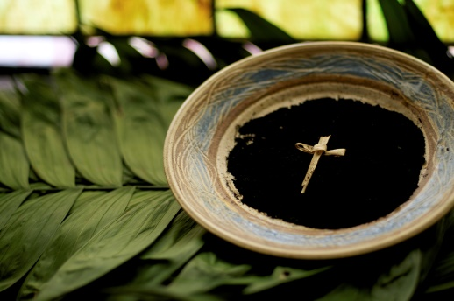



**Objective of the week:**

To encourage to seek the Kingdom in the community where everyone find his/her place.

To discover the value of each one as the Father did.