**INTRODUCTION**

Last week we were reminded once again of our identity as children of God being a member of this family.

When we speak of family, it involves relationships among its members having common goals and visions. However, even if we are not biologically brothers and sisters; yet, we are all children of the same father who is in heaven. Our Heavenly Father has a deep concern with his children. We too, the VDMFa must have this feeling rooted from Him and look for our broken siblings back to His loving arms again. It is a tangible sign of our commitment as one big happy and loving family which entails time, prayer, and sacrifice. As we practice our prayer in the Word of God and living it out in our mission, this shows our connectivity. We are together in our journey toward our common goal and vision.

There are also specific elements that characterize the VDMFa: The one, same contemplative-missionary spirituality that arises from the personal experience of God and His call, which generates the style of life according to the Beatitudes, with loving solidarity and a missionary heart. The one, same missionary centered in the Word of God. The sense that the VDMFa as our own family of faith in the Church making of this community a real school of life, communion, and missionary love. A path of formation for the integral growth of the person and of the community as a whole; the assimilation and participation in the Verbum Dei charism from the spiritual and historical heritage of its founder, Fr. Jaime Bonet. (Statutes#6) Let us also remember that a family is not complete without a mother who accompanies her children to give consolation, to give strength, to cheer up, and to pray for, to achieve our goal; and she is our dear Mother Mary who is happy watching over us as we continue her “fiat” today. Let us ask her intercession that we can proceed our journey with her faithfully.

**DYNAMISM OF THE WORD**





L

**MONDAY**

***God calls us to be in this family***

53. The name “family” expresses certain common roots from the Trinitarian source of love, a sense of identity and belonging and a certain closeness in relationships. This signifies friendship, gratuitous, committed, and unconditional love; it entails environments of trust in which each one may grow as a person and as a disciple of Jesus, where the closeness of the other and the gift that each one is for the whole VDMFa can be enjoyed. The term “missionary” introduces this family in the dynamism of charity that is always open, passionate for the world, in a tension toward what not yet is, and yet knowing how to rejoice with gratitude over what already is, as Jesus himself. ***(VDMFa Statutes 53)***

*To belong to this family is not our dream; yet, there is a very special reason why we are in this family. It is because when we’re in our mother’s womb, God saw the longingness and the sincerity of our hearts; fortunately, it is God’s hand that rightly puts us in this community. He puts us in a family where we are fitted to work on, to bridge the gap of His separated children. It is where His love becomes effective and revealed to them through us. Therefore, we need to pray the Word of God everyday to make it the center of our heart and our source of strength to do the mission. Are you blessed as one of God’s chosen ones to be in this VDMFa?*

**TUESDAY**

***God called us to be His disciples***

3. The identity of the VDMFa is expressed in its own name: to be “family”, profoundly “missionary”, at the service of announcing the “Word of God”. The VDMFa gathers in her womb, persons or groups of all states of life, age, culture, and social condition, who participate in one same vocation to be “Verbum Dei”. All of us are united by the common call to identify ourselves personally and in community with Jesus, revealing the face of our One and Triune God in our lives.

***(VDMFa Statutes 3)***

*We are all blessed to belong to this family. As our way of gratitude to the Father, we must work with our common vision. We don’t need to go to foreign lands to reach out our broken brothers and sisters but to choose to love someone instead of condemning them in the family, workplace, and community. When we ask the Lord for pardon for our wrong decisions and ask His help to give us strength to continue in our journey, when we live sincerely and joyfully with others as God’s children, when we offer our daily routine to someone in need is already a mission. Our actions and choices speak about the gospel that can help change others and our environment. How is your following? Is your VD spirit still burning? How do you sustain it?*

**WEDNESDAY**

***We belong to this VDMFa***

“God is Family and integrates us into his family. He has revealed himself to us as a community of life and love, the origin and source of all families, called to be the sacrament and expression of the Family of the Father, the Son and the Holy Spirit. Through Christ we have free access to the Father in one Spirit (Ephesians 2:18). Therefore, we are no longer strangers or foreigners, but fellow citizens of the saints and relatives of God (Ephesians 2:19)”

“The enriching companionship of the Trinity generates in us peculiar families wherein it stands out the respect for every person, the cooperation, the acceptance on the divergences, the tolerance, the patience, the calmness. Families where faith, hope and love become palpable, where fraternal atmosphere of the Kingdom are created.”

***(Familiares de Dios)***

*It is our duty to extend our hands to every people we meet each day with open heart. We should make our day a memorable day with the Lord bringing the lost, the suffering, and the needy. Working for the kingdom of God has no time; it is a day-to-day affair. Let us work together in our own little ways wherever we may be and we should not be ashamed to work for Christ, but rather, be available and accommodate them regardless of age, status, and culture to increase our number. How could you identify yourself being a member of this family? Have you ever fanned the lukewarm faith of our fellow VDMFa?*

**THURSDAY**

***We are committed to work together as a family***

5. Those who participate in this common vocation of the VDMFa are united by the same ideal and commitment to aspire to perfection in charity, propagating to all the world this same fraternal love, vital nucleus of the Kingdom of God[1].

***(VDMFa Statutes 5)***

*The pillars of our VD strengthens our Christian faith. This is the unique privilege that we have in this family. We cannot remain VD by name because it includes responsibility of living in an upright manner – to guard our thoughts, words, and actions. That is why it is very important to each one of us to share our spiritual journey in the Revision of Life to give testimony and light to others how we live our faith daily with all the pressures and temptations of the world. How do you concretize your commitment? Are you doing it everyday, anytime, and anywhere?*

**FRIDAY**

***We are collaborators of Christ***

4. Its goal is the living-out and propagation of the Kingdom of God through prayer, testimony of life, and the ministry of the Word[2], forming apostles of Christ, and creating evangelizing communities. The VDMFa, with the motto of the first disciples of Jesus, “We will dedicate ourselves to prayer and to the ministry of the Word”, and the spirit of the first Christian community[3], concretizes and centers its specific mission in the Word of God. ***(VDMFa Statutes 4)***

*Mother Mary plays a vital role in our life. She is the first committed disciple, most humble and faithful servant of God. She must be our role model in our commitment. Let us always gaze our eyes on Her and examine closely where she got her strength, how she survived with all those challenges, and finished the race of life undefeated. Let us constantly approach our dear Mother Mary and beg her to give us her virtues to face the battle of life victoriously. How often do you call our Mother Mary? Have you ever drawn strength from Her? How could you show devotion to her as our Mother of faith?*

**SATURDAY**

***We are VDMFa forever***

“Driven by the propagation of the life of God for generations, we feel the responsibility of making available to others what our eyes saw, our ears heard and what we experienced and feel in the silent dialogue with the Trinity and Mary, in that atmosphere of Familiarity with God, the foundation of our being a Verbum Dei Family and guarantee of our communion in the charism.” ***(Familiares de Dios)***

*Propagation of faith is touching the lives of our brothers and sisters with light, joyful, and compassionate disposition. Let us go out from our comfort zone and let us tell them the joy, the light and the life that we have received from Christ in this community. In what way can you radiate the light of Christ to others?*

**SUNDAY**

**4th Sunday in Ordinary Time**

**1st Reading:** Zephaniah 2:3; 3:12-13

**Responsorial Psalm:** Psalm 146

**2nd Reading:** 1Corinthians 1:26-31

**Gospel:** Matthew 5:1-12aw 2:1-123a, 5-6ing the idenity . We pray that they may again always pray for our brothers and sisters who has long been

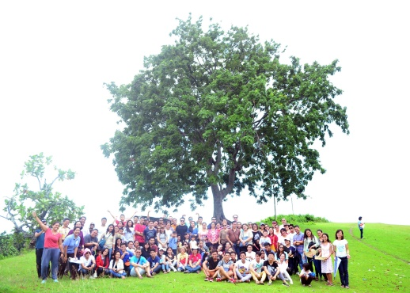

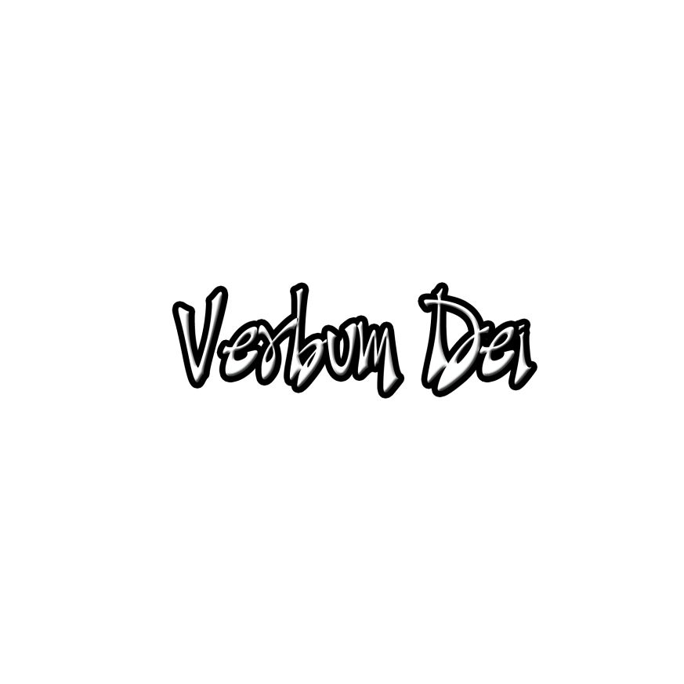

**GUIDELINES FOR PRAYER**



***“Verbum Dei Missionary Family”***



January 23-29, 2017

**General Theme:** Enlarge the space of your tent.

**General Objectives:**

That the disciples renew their experience to be members of this great Family that God has gathered and has chosen in His name in order to welcome many people and continue to express His Trinitarian and Missionary identity through this Family.

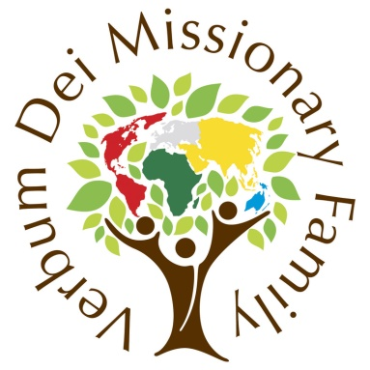

**Objective of the week:**

To renew the call of God to be a Verbum Dei Missionary Family that is united in the same spirit and ideal.

1. Cf. CFMVD 9; LG 40
2. Acts 6:4
3. Cf. Acts 2:42-47; 4:32-35