**INTRODUCTION**

Rejoice! God is with us.

This week we celebrate the Epiphany.

The word 'Epiphany' comes from Greek and means 'manifestation'. It celebrates 'the revelation of God in his Son as human in Jesus Christ'. How blessed we are that God became human in order to dwell in us, to build His family with us.

“God is family and integrates us into His Family. He has revealed himself to us as a community of life and love, the origin and source of all families, called to be the sacrament and expression of the Family of the Father, the Son and the Holy Spirit. Through Christ, we have free access to the Father in one Spirit (Ephesians 2:18)Therefore, we are no longer strangers or foreigners, but fellow citizens of the saints and relatives of God (Ephesians 2;19)

The Word became flesh in Jesus Christ and lives with us. He was baptized with the Holy Spirit and receive His identity as prophet, priest and King. We too, by the virtue of our baptism, the identity of Jesus has also been revealed in us, being prophet, priest and King. Our baptism is much more than merely a symbolic sign of belonging to the church. It is a means by which a person is incorporated into Christ, becoming a member of His mystical body. We become His prophet the beacon of His Light. Illumination is desperately needed in our increasingly secularized society. We are His priest, the bridge between God and our brothers and sisters who are disconnected from Him. We are His King, the builder of His kingdom here on earth. In our real cultivation of a real friendship with theliving Christ, we act out our identity and purpose.

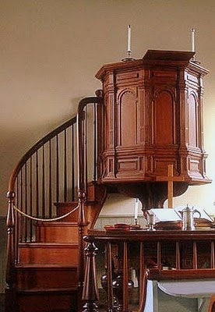**DYNAMISM OF THE WORD**





L

**MONDAY**

***BE A PROPHET***

*2 After Jesus was born in Bethlehem in Judea, during the time of King Herod, Magi[a] from the east came to Jerusalem 2 and asked, “Where is the one who has been born king of the Jews? We saw his star when it rose and have come to worship him.”*

3 When King Herod heard this he was disturbed, and all Jerusalem with him. 4 When he had called together all the people’s chief priests and teachers of the law, he asked them where the Messiah was to be born. 5 “In Bethlehem in Judea,” they replied, “for this is what the prophet has written:6 “‘But you, Bethlehem, in the land of Judah” ,are by no means least among the rulers of Judah; for out of you will come a ruler who will shepherd my people Israel.”

7 Then Herod called the Magi secretly and found out from them the exact time the star had appeared. 8 He sent them to Bethlehem and said, “Go and search carefully for the child. As soon as you find him, report to me, so that I too may go and worship him.”

9 After they had heard the king, they went on their way, and the star they had seen when it rose went ahead of them until it stopped over the place where the child was. 10 When they saw the star, they were overjoyed. 11 On coming to the house, they saw the child with his mother Mary, and they bowed down and worshiped him. Then they opened their treasures and presented him with gifts of gold, frankincense and myrrh. 12 And having been warned in a dream not to go back to Herod, they returned to their country by another route.

***(Matthew 1:2-12)***

*By virtue of our baptism, we become prophet of God, one that leads others to Jesus. Like the Magi, let us recognize the Light which appears in front of us and exercise our prophetic role as disciples of Christ to lead others back to Him. Let us continue to speak the word of Jesus, the Word of Love that can bring healing and peace.*

**TUESDAY**

***BE A PRIEST***

1 In the beginning was the Word, and the Word was with God, and the Word was God. 2 He was with God in the beginning. 3 Through him all things were made; without him nothing was made that has been made. 4 In him was life, and that life was the light of all mankind. 5 The light shines in the darkness, and the darkness has not overcome[a] it.

6 There was a man sent from God whose name was John. 7 He came as a witness to testify concerning that light, so that through him all might believe. 8 He himself was not the light; he came only as a witness to the light. 9 The true light that gives light to everyone was coming into the world. 10 He was in the world, and though the world was made through him, the world did not recognize him. 11 He came to that which was his own, but his own did not receive him. 12 Yet to all who did receive him, to those who believed in his name, he gave the right to become children of God— 13 children born not of natural descent, nor of human decision or a husband’s will, but born of God. 14 The Word became flesh and made his dwelling among us. We have seen his glory, the glory of the one and only Son, who came from the Father, full of grace and truth. ***(John 1:1-14)***

*The Word became flesh in Christ Jesus and He became the bridge of man to the Father. This priesthood identity of Jesus has been bestowed on us by the virtue of our baptism. We are to foster holiness in the measure that we serve as a bridge between Jesus and our fellowmen*.

**WEDNESDAY**

***BE A KING***

"Do not be afraid, little flock, for your Father has been pleased to give you the kingdom. ***(Luke 12:32)***

*Through our anointing in the baptism, we share the identity of Jesus’ Kingship. We are to build the kingdom of God in others heart. Being a King, we are called to order the charism within our Verbum Dei community so as to direct that community toward God. We are also called to set free our brothers and sisters who became captives of this world by reaching out to them through His WORDS. Who are the concrete people whom you are called to build the Kingdom of God?*

**THURSDAY**

***BE A FAMILY for OTHERS***

18 For through him we both have access to the Father by one Spirit*.*19 Consequently, you are no longer foreigners and strangers, but fellow citizens with God’s people and also members of his household, 20 built on the foundation of the apostles and prophets, with Christ Jesus himself as the chief cornerstone. 21 In him the whole building is joined together and rises to become a holy temple in the Lord. 22 And in him you too are being built together to become a dwelling in which God lives by his Spirit. **(*Ephesians 2:18-22)***

*What a cause for joy, gratitude and continued obedience! We are now citizens in the Kingdom, and identified with others who enjoyed the same relationship with God. If we are members of the household of God, we should renew our gratefulness to God and our daily devotion to Him and encourage others to do the same.*

**FRIDAY**

***BE A SOURCE OF HIS FAMILY***

“And I pray that you, being rooted and established in love, may have power, together with all the Lord’holy people, to grasp how wide and long and high and deep is the love of Christ, and to know this love that surpasses knowledge— that you may be filled to the measure of all the fullness of God***.***

***( Ephesians 3:17-19)***

*The living out of the fraternal love established by Jesus, centers the existence of the VDMFa in making the Kingdom visible and committing ourselves to it. The shared love of the Trinity unites us with stable bonds of love and friendship, and makes it possible to present to the world, in* *a credible way, the project of love of God the Father: that we may come to love as Jesus has loved us, under the power of his Spirit.* ***(VDMFa Statutes #55)***

**SATURDAY**

***BE A SACRAMENT AND EXPRESSION OF BEING FAMILY***

20 “My prayer is not for them alone. I pray also for those who will believe in me through their message, 21 that all of them may be one, Father, just as you are in me and I am in you. May they also be in us so that the world may believe that you have sent me.

***( John 17:20-21)***

*Jesus was praying for us and for the future. His prayer focuses on unity, on all being one with Him, The Father and the Holy Spirit. Let us also do the same. Let us always pray for our brothers and sisters who has long been detached from our Verbum Dei community. We pray that they may again one with us in exercising the identity of Christ.*

**SUNDAY**

**1st Reading:** Isaiah 49:3,5-6

**Responsorial Ps:** Psalm40

**2nd Reading:** 1Cor. 1:1-3

**Gospel:** John 1:29-34w 2:1-123a, 5-6ing the idenity . We pray that they may again always pray for our brothers and sisters who has long been

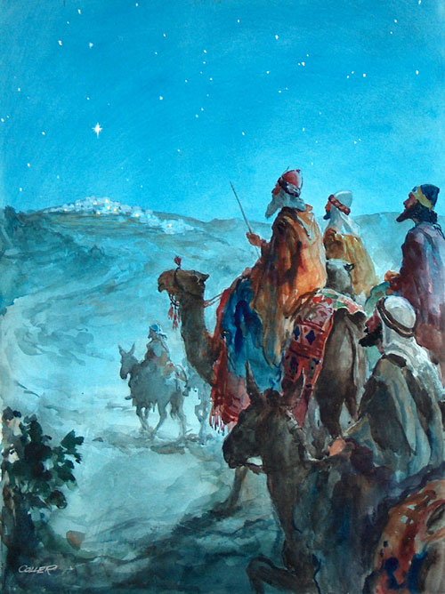



**GUIDELINES FOR PRAYER**



***“VDMFa: God reveals you His identity”(Epiphany)***



January 9-14, 2017

**General Theme:** Enlarge the space of your tent.

**General Objectives:**

That the disciples renew their experience to be members of this great Family that God has gathered and has chosen in His name in order to welcome many people and continue to express His Trinitarian and Missionary identity through this Family.

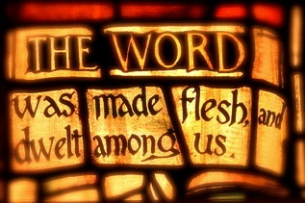

**Objective of the week:**

To deepen in the Trinitarian identity of God as origin and source that unite and sustain together this family.