INTRODUCTION

“And I will ask the Father, and he will give you another advocate to help you and be with you forever—the Spirit of truth . . . But you know him, for he lives with you and will be in you.” (John 14:16-17)
This was the promise of Jesus to His disciples—the Helper, the Paraclete, the Consoler—the Spirit of Truth. The one who will lead us into all truth and reveals God, for no one comprehends the thoughts of God but only God's Spirit—the One who will teach us everything, remind us of all truth Christ said and bear witness to Him.
This week let us allow the Holy Spirit to work within us in order to learn each day how Jesus transmitted its seven gifts to the Samaritan Woman (John 4:1-30) thus making her from thirsty woman into a fountain of life-giving water for the Samaritans. One of the symbols of the Holy Spirit is water; the symbolism of water signifies the Holy Spirit's action in Baptism. Thus the Spirit is also personally the living water welling up from Christ crucified as its source and welling up in us to eternal life (CCC 694).
As Verbum Dei we are called to be spirit-filled evangelizers. In order to do so, we need to activate those gifts from our Baptism in our own lives so that we may have better actions, make our decisions more free, and our thoughts more directed toward the essential. The Spirit helps us worship God according to the truth, for God seeks such worshippers who enter into intimate personal contact with Him.

MONDAY
Jesus transmitted the Spirit—
Gift of Wisdom

John 4:1-4 Now when Jesus learned that the Pharisees had heard that Jesus was making and baptizing more disciples than John ² (although Jesus himself was not baptizing, just his disciples), ³ he left Judea and returned to Galilee. ⁴ He had to pass through Samaria.
Luke 4:42-43 ⁴² At daybreak, Jesus left and went to a deserted place. The crowds went looking for him, and when they came to him, they tried to prevent him from leaving them. ⁴³ But he said to them, "To the other towns also I must proclaim the good news of the kingdom of God, because for this purpose I have been sent."
The gift of wisdom enables us to constantly search actively the will of God, totally obeying and surrendering to do it till the end. This comes from intimacy with God, the intimate relationship we have with the Father from our daily dialogue with Him. When we are in communion with the Lord, the Holy Spirit transfigures our hearts, making us see the world, the situations, problems through the eyes of God—hearing with God’s ears, loving with God's heart, directing things with God's judgment. This gift of wisdom cannot be invented or obtained by ourselves. This gift is given to those who make themselves docile to the Holy Spirit. How docile are we in order that we can transmit this gift of wisdom to others through our daily lives?
TUESDAY
Jesus transmitted the Spirit—
Gift of Knowledge

John 4:6-9 ⁶ Jacob's well was there. Jesus, tired from his journey, sat down there at the well. It was about noon. ⁷ A woman of Samaria came to draw water. Jesus said to her, "Give me a drink." ⁸ His disciples had gone into the town to buy food. ⁹ The Samaritan woman said to him, "How can you, a Jew, ask me, a Samaritan woman, for a drink?" (For Jews use nothing in common with Samaritans.)
Genesis 1:31 God saw all that he had made, and it was very good.
This gift of knowledge is not the knowledge that we get from the books or what we have acquired in the class. This is a knowledge that comes from prayer, knowing God – who He is for us, who we are to Him, and who our neighbour is.
A gift which leads us to grasp, through others, the greatness and love of God and His profound relationship with every creature. It sets us in profound harmony with the Creator and allows us to participate in the clarity of His vision and His judgment. It is in this perspective that we manage to accept man and woman as the summit of creation, as the fulfilment of a plan of love that is impressed in each one of us and that allows us to recognize one another as brothers and sisters. How do we look at other creations, our brothers and sisters? Do we see in them the goodness and beauty of God's creation?
WEDNESDAY
Jesus transmitted the Spirit—
Gifts of Counsel and Fortitude

John 4:10-14 ¹⁰ Jesus answered and said to her, "If you knew the gift of God and who is saying to you, 'Give me a drink,' you would have asked him and he would have given you living water." ¹¹ (The woman) said to him, "Sir, you do not even have a bucket and the cistern is deep; where then can you get this living water? ¹² Are you greater than our father Jacob, who gave us this cistern and drank from it himself with his children and his flocks?" ¹³ Jesus answered and said to her, "Everyone who drinks this water will be thirsty again; ¹⁴ but whoever drinks the water I shall give will never thirst; the water I shall give will become in him a spring of water welling up to eternal life."
Luke 8:5-8 5 “A farmer went out to sow his seed. As he was scattering the seed, some fell along the path; it was trampled on, and the birds ate it up. 6 Some fell on rocky ground, and when it came up, the plants withered because they had no moisture. 7 Other seed fell among thorns, which grew up with it and choked the plants. 8 Still other seed fell on good soil. It came up and yielded a crop, a hundred times more than was sown.”
When he said this, he called out, “Whoever has ears to hear, let them hear.”
Gift of counsel "enables us to see and choose correctly what will help most to the glory of God and our own salvation." Because of this gift, Christians need not fear to stand up for the truths of the Faith, for the Holy Spirit will guide us in defending those truths.
Gift of fortitude gives us the strength to follow through the actions suggested by the gift of counsel. While it is sometimes called courage, it goes beyond what we normally think of. It is the virtue of the martyrs that allows them to suffer death rather than to renounce the Christian Faith.
THURSDAY
Jesus transmitted the Spirit—
Gift of Understanding

John 4:15-18 ¹⁵ The woman said to him, "Sir, give me this water, so that I may not be thirsty or have to keep coming here to draw water." ¹⁶ Jesus said to her, "Go call your husband and come back." ¹⁷ The woman answered and said to him, "I do not have a husband." Jesus answered her, "You are right in saying, 'I do not have a husband.' ¹⁸ For you have had five husbands, and the one you have now is not your husband. What you have said is true."
Gift of understanding is sometimes called "the science of the saints," because "it enables those who have the gift to discern easily and effectively between the impulses of temptation and the inspirations of grace." Judging all things in the light of divine truth, we can more easily distinguish between the promptings of God and the subtle wiles of the devil.
Jesus desired to send us the Holy Spirit so that we might have this gift, so that all of us might understand things as God understands them, with the mind of God.

FRIDAY
Jesus transmitted the Spirit—
Gift of Piety

John 4:19-30 ¹⁹ The woman said to him, "Sir, I can see that you are a prophet. ²⁰ Our ancestors worshiped on this mountain; but you people say that the place to worship is in Jerusalem." ²¹ Jesus said to her, "Believe me, woman, the hour is coming when you will worship the Father neither on this mountain nor in Jerusalem. ²² You people worship what you do not understand; we worship what we understand, because salvation is from the Jews. ²³ But the hour is coming, and is now here, when true worshipers will worship the Father in Spirit and truth; and indeed the Father seeks such people to worship him. ²⁴ God is Spirit, and those who worship him must worship in Spirit and truth." ²⁵ The woman said to him, "I know that the Messiah is coming, the one called the Anointed; when he comes, he will tell us everything." ²⁶ Jesus said to her, "I am he, the one who is speaking with you." ²⁷ At that moment his disciples returned, and were amazed that he was talking with a woman, but still no one said, "What are you looking for?" or "Why are you talking with her?" ²⁸ The woman left her water jar and went into the town and said to the people, ²⁹ "Come see a man who told me everything I have done. Could he possibly be the Messiah?" ³⁰ They went out of the town and came to him.

Gift of piety is the perfection of the virtue of religion. While we tend to think of religion today as the external elements of our faith, it really means the willingness to worship and to serve God. Piety takes that willingness beyond a sense of duty so that we desire to worship God and to serve Him out of love, the way that we desire to honor our parents and do what they wish.
SATURDAY
Jesus transmitted the Spirit—
Gift of Fear of the Lord

John 4:31-42 ³¹ Meanwhile, the disciples urged him, "Rabbi, eat." ³² But he said to them, "I have food to eat of which you do not know." ³³ So the disciples said to one another, "Could someone have brought him something to eat?" ³⁴ Jesus said to them, "My food is to do the will of the one who sent me and to finish his work. ³⁵ Do you not say, 'In four months the harvest will be here'? I tell you, look up and see the fields ripe for the harvest. ³⁶ The reaper is already receiving his payment and gathering crops for eternal life, so that the sower and reaper can rejoice together. ³⁷ For here the saying is verified that 'One sows and another reaps.' ³⁸ I sent you to reap what you have not worked for; others have done the work, and you are sharing the fruits of their work." ³⁹ Many of the Samaritans of that town began to believe in him because of the word of the woman who testified, "He told me everything I have done." ⁴⁰ When the Samaritans came to him, they invited him to stay with them; and he stayed there two days. ⁴¹ Many more began to believe in him because of his word, ⁴² and they said to the woman, "We no longer believe because of your word; for we have heard for ourselves, and we know that this is truly the savior of the world."
Gift of fear of the Lord: This gift of the Holy Spirit gives us the desire not to offend God, as well as the certainty that God will supply us the grace that we need in order to keep from offending Him. Our desire not to offend God is more than simply a sense of duty; like piety, the fear of the Lord arises out of love.
SUNDAY
The Twelfth Sunday in Ordinary Time

1st Reading: Jer 20:10-13
Ps: Psalm 69
2nd Reading: Rom 5:12-15
Gospel: Mat 10:26-33

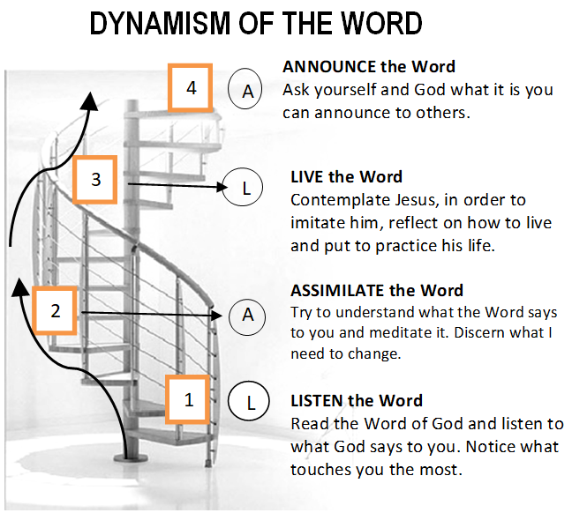

GUIDELINES FOR PRAYER

“The water I shall give will become in you a spring of water.”
(John 4:14)

19-25 June, 2017

General Theme:
Jesus himself drew near and walked along with them.” (Lk.24:15)

General Objective:
To teach the apostles to accompany the new people with their life and their words based on how Jesus accompanied His apostles after the resurrection.

Objective of the week:

To learn from Jesus the importance to transmit the Spirit in our mission.

