INTRODUCTION

We just celebrate the birthday of the Catholic(Universal) Church born from Pentecost event with the descending of the Holy Spirit. With the coming of the Spirit the apostles felt capable of fulfilling the mission entrusted to them. They felt full of strength. It is precisely this that the Holy Spirit worked in them and this is continually at work in the Church, through their successors. (cf. Pope Saint John Paul II Encyclical, Dominum et Vivicantem 25)

We have been praying during the month of May on how Jesus is accompanying us His apostles and learning from him that we may teach others to do the same. As we enter this month of June we have been reminded of the gift of the Holy Spirit whom we are called to transmit(activate) in our mission. It is with the very same image on the Visitation of Mary to Elizabeth who transmitted(activated) the Holy Spirit. She greeted her cousin Elizabeth, and at the sound of her voice, John quickened in his mother's womb and leapt for joy. “I have come,” said Christ, “that they may have life and may have it more abundantly.” [Jn. 10, 10] Even before He was born His presence gave life.( The Reed of God, Caryll Houselander) Just as Jesus himself said that it is the Spirit that gives life activated thru the words that He preached,(Cf. John 6:63) in the same way Jesus is asking us to do the same, to learn its importance to transmit the Spirit in our mission. Thus others may experience that fullness of life that they deserved the reason Jesus came for, making them and us a vast army for the Lord.(Cf. Ezekiel 37:10)

MONDAY
Not simply do the mission
but transmit in it the Spirit

Then he said to me: Prophesy over these bones, and say to them: Dry bones, hear the word of the LORD! ⁵ Thus says the Lord GOD to these bones: See! I will bring spirit into you, that you may come to life. ⁶ I will put sinews upon you, make flesh grow over you, cover you with skin, and put spirit in you so that you may come to life and know that I am the LORD. ⁷ I prophesied as I had been told, and even as I was prophesying I heard a noise; it was a rattling as the bones came together, bone joining bone. ⁸ I saw the sinews and the flesh come upon them, and the skin cover them, but there was no spirit in them. 9 Then he said to me: Prophesy to the spirit, prophesy, son of man, and say to the spirit: Thus says the Lord GOD: From the four winds come, O spirit, and breathe into these slain that they may come to life. I prophesied as he told me, and the spirit came into them; they came alive and stood upright, a vast army. (Ezekiel 37:4-10)

During those days Mary set out and traveled to the hill country in haste to a town of Judah, where she entered the house of Zechariah and greeted Elizabeth.When Elizabeth heard Mary's greeting, the infant leaped in her womb, and Elizabeth, filled with the holy Spirit, cried out in a loud voice and said, "Most blessed are you among women, and blessed is the fruit of your womb. And how does this happen to me, that the mother of my Lord should come to me? For at the moment the sound of your greeting reached my ears, the infant in my womb leaped for joy. Blessed are you who believed that what was spoken to you by the Lord would be fulfilled. ( Luke 1:39-45)

As a follower entrusted to participate in His mission, we are invited to transmit the same spirit of our charism, based on what we profoundly pray and live.

TUESDAY
Not just making others listeners
of the Word but proclaimers

A man named Simon used to practice magic in the city and astounded the people of Samaria, claiming to be someone great. All of them, from the least to the greatest, paid attention to him, saying, "This man is the 'Power of God' that is called 'Great.'" They paid attention to him because he had astounded them by his magic for a long time, but once they began to believe Philip as he preached the good news about the kingdom of God and the name of Jesus Christ, men and women alike were baptized. Even Simon himself believed and, after being baptized, became devoted to Philip; and when he saw the signs and mighty deeds that were occurring, he was astounded. Now when the apostles in Jerusalem heard that Samaria had accepted the word of God, they sent them Peter and John, who went down and prayed for them, that they might receive the holy Spirit, for it had not yet fallen upon any of them; they had only been baptized in the name of the Lord Jesus. Then they laid hands on them and they received the Holy Spirit. When Simon saw that the Spirit was conferred by the laying on of the apostles' hands, he offered them money and said, "Give me this power too, so that anyone upon whom I lay my hands may receive the holy Spirit." But Peter said to him, "May your money perish with you, because you thought that you could buy the gift of God with money. You have no share or lot in this matter, for your heart is not upright before God. Repent of this wickedness of yours and pray to the Lord that, if possible, your intention may be forgiven. For I see that you are filled with bitter gall and are in the bonds of iniquity." Simon said in reply, "Pray for me to the Lord, that nothing of what you have said may come upon me." (Acts 8:9-24)

We are called to bring and lead others to proclaim as well the wonders that God has been doing in their lives and not simply to remain as eternal listeners.
WEDNESDAY
The Spirit of the mission is Love

If I speak in human and angelic tongues but do not have love, I am a resounding gong or a clashing cymbal. And if I have the gift of prophecy and comprehend all mysteries and all knowledge; if I have all faith so as to move mountains but do not have love, I am nothing. If I give away everything I own, and if I hand my body over so that I may boast but do not have love, I gain nothing. (1 Corinthians 13:1-3)

What has to move us if not our love for God and for our brethren - the same spirit that moves Jesus in his entire life. “The world must know that I love the Father and so I do what He has commanded me to do”(cf. Jn.14:31) This love has already been poured out into our hearts.

THURSDAY
It’s the oil before the wine

But a Samaritan traveler who came upon him was moved with compassion at the sight. ³⁴ He approached the victim, poured oil(first) and (then)wine over his wounds and bandaged them. Then he lifted him up on his own animal, took him to an inn and cared for him.
(Luke 10:33-34)

“The oil before the wine” is the proper way to give remedies. We who are called to bring forth life through the Word is being invited: to pray first what we are to transmit to others, then strive to live and put into practice what we are to announce.
FRIDAY
It’s the cloth over all the clothes

As the chosen of God, then, the holy people whom he loves, you are to be clothed in heartfelt compassion, in generosity and humility, gentleness and patience. ¹³ Bear with one another; forgive each other if one of you has a complaint against another. The Lord has forgiven you; now you must do the same. ¹⁴ Over all these clothes, put on love, the perfect bond. (Colossians 3:12-14)

We concretely love through our charism, giving the Word of God. It’s the cloth of love we need to put over all the “clothes”.We save someone when we put the person in contact with God. Let us not get tired in accompanying others to Him, for them to have that experience of His love. This is to make disciples.

SATURDAY
It’s the Spirit of Peace
thru Forgiveness

¹⁹ On the evening of that first day of the week, when the doors were locked, where the disciples were, for fear of the Jews, Jesus came and stood in their midst and said to them, "Peace be with you." ²⁰ When he had said this, he showed them his hands and his side. The disciples rejoiced when they saw the Lord. ²¹ (Jesus) said to them again, "Peace be with you. As the Father has sent me, so I send you." And when he had said this, he breathed on them and said to them, "Receive the holy Spirit. ²³ Whose sins you forgive are forgiven them, and whose sins you retain are retained." (John 20:19-23)

Continue to allow God to do wonders through us for others.In doing so, we can make more disciples. What a peace it brings in doing His will, and in knowing that the Holy Spirit works in the limitation we may find in ourselves.

SUNDAY
Solemnity of the Most Holy Trinity: Ex 34:3-6, 8-9/ Ps 34:2-3, 6-7, 8-9/ Mt 5:1-12

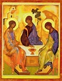

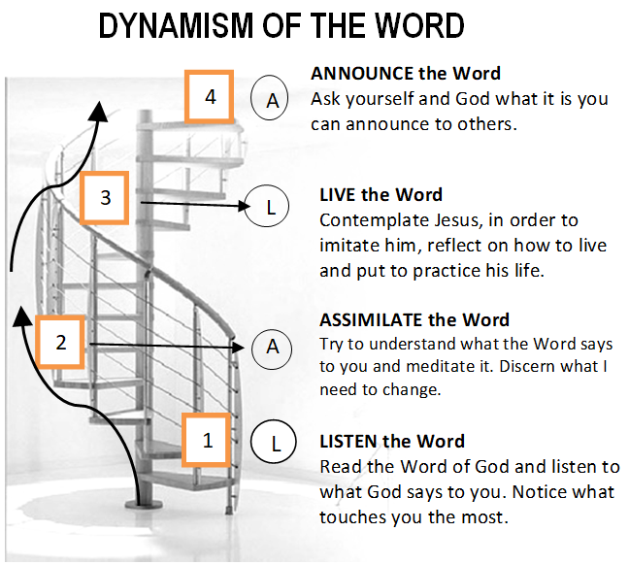

GUIDELINES FOR PRAYER

“Receive the Holy Spirit”
(John 20:22)
June 5 - 11, 2017

General Objective:
To learn the Importance to transmit the Spirit in our mission. (2Kings 2:9)

Objective of the week:
To learn to transmit the Spirit in our mission.

