Introduction

For the past weeks, we deepened on how preaching and the way we preach as Verbum Dei transforms the Mystical Body of Christ. It is a gift to speak on behalf of God and at the same time a responsibility because it demands that we be transformed first.

Our personal transformation and conformation to Christ is a journey we walk every day; that is why we continue to deepen on our sources of spirituality as Verbum Dei because these are the specific and particular paths that would form us to be apostles of the Word—our unique call and response in the Church and in the world.

Let us discover bit by bit the generous love of God in our daily life as we experience it in a truly concrete and tangible way as we come in contact with the Eucharist. We have our own relationship with the Eucharist, yet the invitation now is to know more, to taste and see how sweet it is, how real the presence and love of God is in the sacrament and sacrifice of the Eucharist. It is in our daily encounter with the Eucharist that we are transformed into him, becoming ourselves Christ who is communion, hope, peace, love and the tenderness and gentleness of God.

We ask for the grace of faith to be open and to believe in the human and divine love that is given for us in the Eucharist because without faith it would be difficult to see beyond the bread and wine, and more difficult to trust that we are transformed into it.

MONDAY
“He loved them to the very end”

John 13:1-9 1It was now the day before the Passover Festival. Jesus knew that the hour had come for him to leave this world and go to the Father. He had always loved those in the world who were his own, and he loved them to the very end.
Jesus and his disciples were at supper. The Devil had already put into the heart of Judas, the son of Simon Iscariot, the thought of betraying Jesus. The Devil… betraying Jesus; or The Devil had already decided that Judas, the son of Simon Iscariot, would betray Jesus. Jesus knew that the Father had given him complete power; he knew that he had come from God and was going to God. So he rose from the table, took off his outer garment, and tied a towel round his waist. Then he poured some water into a basin and began to wash the disciples' feet and dry them with the towel round his waist. 6He came to Simon Peter, who said to him, “Are you going to wash my feet, Lord?”
Jesus answered him, “You do not understand now what I am doing, but you will understand later.”
Peter declared, “Never at any time will you wash my feet!”
“If I do not wash your feet,” Jesus answered, “you will no longer be my disciple.”
Simon Peter answered, “Lord, do not wash only my feet, then! Wash my hands and head, too!”

Jesus loved and was in love with those that the Father has given to him up to the very end and with his all to the point of giving his body for them in the last supper. But even from the very beginning of journeying with them, he has loved them with the same intensity and quality—a love that desires for communion. Let us be open then to receive his constantly generous love and self-giving which he continues to give to us today.

TUESDAY
“This is my body given for you”

Luke 22:14-20 When the hour came, Jesus took his place at the table with the apostles. He said to them, “I have wanted so much to eat this Passover meal with you before I suffer! For I tell you, I will never eat it until it is given its full meaning in the Kingdom of God.”
Then Jesus took a cup, gave thanks to God, and said, “Take this and share it among yourselves. I tell you that from now on I will not drink this wine until the Kingdom of God comes.”
Then he took a piece of bread, gave thanks to God, broke it, and gave it to them, saying, “This is my body, which is given for you. Do this in memory of me.” In the same way, he gave them the cup after the supper, saying, “This cup is God's new covenant sealed with my blood, which is poured out for you.

Jesus desired so much to be one with his disciples, his friends, to the point of giving himself to them as food, as bread, in order that they might eat him and be one with him. It is always the longing of our Lover to be in communion with the beloved. The Eucharist is a most generous gesture of love as Jesus made himself Food—to nourish us at the same time to be closest to us.

WEDNESDAY
“The greatest love is to give your life”

John 15:11-13 “I have told you this so that my joy may be in you and that your joy may be complete. My commandment is this: love one another, just as I love you. The greatest love a person can have for his friends is to give his life for them.

Jesus in the Eucharist loves us with a generous love. Generosity is a virtue of the soul which finds its joy and satisfaction in giving more than receiving. A generous person gives his life (time, talents) and forgets that he has given. Giving enlarges our heart and makes us grow in our capacity to love.

THURSDAY
“This is my blood, which seals God’s covenant poured out for many”

Isaiah 53:10-12
The LORD says,
“It was my will that he should suffer;
his death was a sacrifice to bring forgiveness.And so he will see his descendants;he will live a long life,and through him my purpose will succeed.After a life of suffering, he will again have joy;he will know that he did not suffer in vain.My devoted servant, with whom I am pleased,will bear the punishment of many and for his sake I will forgive them. And so I will give him a place of honour,a place among the great and powerful.He willingly gave his life
and shared the fate of evil men.He took the place of many sinners and prayed that they might be forgiven.”

Matthew 26:27 Then he took a cup, gave thanks to God, and gave it to them. “Drink it, all of you,” he said; ”this is my blood, which seals God's covenant, my blood poured out for many for the forgiveness of sins. I tell you, I will never again drink this wine until the day I drink the new wine with you in my Father's Kingdom.”

CCC 1367 The sacrifice of Christ and the sacrifice of the Eucharist are one single sacrifice: "The victim is one and the same: the same now offers through the ministry of priests, who then offered himself on the cross; only the manner of offering is different." "And since in this divine sacrifice which is celebrated in the Mass, the same Christ who offered himself once in a bloody manner on the altar of the cross is contained and is offered in an unbloody manner. . . this sacrifice is truly propitiatory."

It is God’s deepest desire that we be with him forever. So great is this desire that Jesus became the Eucharist—the sacrifice of redemption who seals the new covenant between God and humankind.

FRIDAY
“Blood of my blood and flesh of my flesh”

1 Corinthians 10:15-16 I speak to you as sensible people; judge for yourselves what I say. the cup we use in the Lord's Supper and for which we give thanks to God: when we drink from it, we are sharing in the blood of Christ. And the bread we break: when we eat it, we are sharing in the body of Christ.

Jesus in the Eucharist becomes part of my life, part of my being. “In the Eucharist, Jesus is completely anchored, as the theologian St. Thomas said, ‘On the cross, the divinity was hidden, but in the Eucharist, his humanity is hidden.’ There is no doubt that Jesus in the Eucharist, gets into our body embedding itself as an anti-body, and by the action of the Eucharist in us, we are becoming another Christ.” (Familiaris de Dios, p.424)

SATURDAY
“When I am lifted up from the earth, I will draw everyone to me”

John 12:24, 32-33 I am telling you the truth: a grain of wheat remains no more than a single grain unless it is dropped into the ground and dies. If it does die, then it produces many grains.
When I am lifted up from the earth, I will draw everyone to me.” (In saying this he indicated the kind of death he was going to suffer.)

CCC 1359 The Eucharist, the sacrament of our salvation accomplished by Christ on the cross, is also a sacrifice of praise in thanksgiving for the work of creation. In the Eucharistic sacrifice the whole of creation loved by God is presented to the Father through the death and the Resurrection of Christ. Through Christ the Church can offer the sacrifice of praise in thanksgiving for all that God has made good, beautiful, and just in creation and in humanity.

The generosity of God in the Eucharist, with all its divine and human love, is for all people in all times. It is for all humanity that Jesus gave his life—no one is unreachable.

Are there aspects in your life that you consciously keep out of Jesus’ reach?

SUNDAY
Sixth Sunday of Easter

1st Reading – Acts 10:25-26, 34-35, 44-48
Responsorial Psalm – Psalm 98
2nd Reading –1 John 4:7-10
Gospel – John 15:9-17

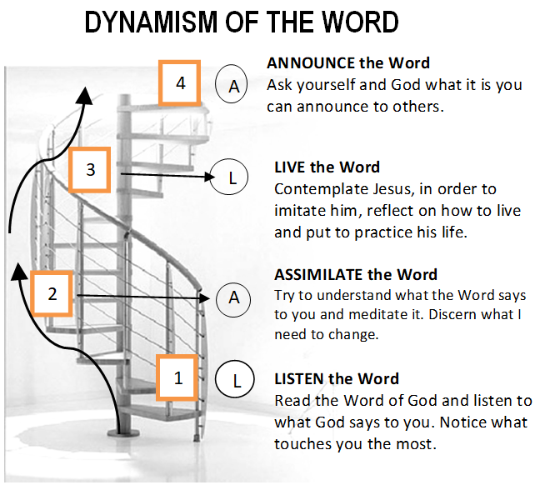

Guidelines for Prayer

“He loved them to the very end”

John 13:1c

April 30-May 6, 2018
Enlarge the space of your tent for the Verbum Dei Spirituality

General Objectives:
- to discover the generous love of God in our daily life as one experience it being in contact with this love in the Eucharist

Objective of the week:
-to discover the generous love of God who in the sacrifice and sacrament of the Eucharist gives us his divine-human love

