Introduction

Our God who is a perfect communion of love between the Father, the Son, and the Holy Spirit has made us to sharers of his inmost life.Jesus in the offering of himself in the Eucharist makes it possible. It is absolutely a free gift.

The Eucharist is God’s gift to us in our journey.What we just celebrated, the feast of the Most Holy Trinity is a mystery of our faith, a mystery of the Trinitarian love where we are called by grace to participate.(cf.Sacramentum Caritatis,8) How great that at this point of time as we journey towards the celebration of the feast of Corpus Christi (Solemnity of the Body and Blood of Christ), we are deepening on the Eucharist, which is the source and summit of our Christian life.(cf. Lumen Gentium 11)

We know that we are created for a true and eternal happiness that our God alone can give. For us to go forward in that direction and be guided towards our final goal,who is Jesus, He makes himself present to us in every Eucharistic celebration. What the Eucharist can do to us!What a power it has for the one who receives Him. It can strengthen, create, build, sustain, and nourish us.

Jesus in the Eucharist is richly, totally giving himself that we may find and receive through his passion the life we too are called to live in the spirit of love through our faith, self-giving, communion, solidarity, unity and humility.

MONDAY
“Eucharist:source of love and life”

On the last and most important day of the festival Jesus stood up and said in a loud voice, “Whoever is thirsty should come to me, and whoever believes in me should drink. As the scripture says, ‘Streams of life-giving water will pour out from his side.’” Jesus said this about the Spirit, which those who believed in him were going to receive. At that time the Spirit had not yet been given, because Jesus had not been raised to glory.(Jn.7:37-39)

The Eucharist is a source of love and life that whoever drink and eat Christ’s life, comes from within life and love.As disciples and apostles, we too experience dryness in our relationship with God. But Jesus' invitation for us, especially in the Eucharist, is to believe. Have faith that through this sacrament of communion in the Eucharist, Jesus constantly gives us, pours out for us and into our hearts the stream of grace, love and mercy. So that filled with this, we also become capable of bringing Jesus to those who also thirst for the living water from the one true source of life.

What attitude do I have as I approach him in the eucharist?

TUESDAY
“Eucharist: source of self giving”

Pope John Paul II stated that the moral life "has the value of a 'spiritual worship' (Rom 12:1; cf. Phil 3:3), flowing from and nourished by that inexhaustible source of holiness and glorification of God, which is found in the sacraments, especially in the Eucharist: by sharing in the sacrifice of the Cross, the Christian partakes of Christ's self-giving love and is equipped and committed to live this same charity in all his thoughts and deeds". In a word, "'worship' itself, Eucharistic communion, includes the reality both of being loved and of loving others in return. A Eucharist, which does not pass over into the concrete practice of love is intrinsically fragmented".

Jesus calls us to partake of His infinite source of love for all. In what realities that we face now does Jesus invites us to concretely give ourselves with love?

WEDNESDAY
“Eucharist: Source of communion”

I pray that they may all be one. Father! May they be in us, just as you are in me and I am in you. May they be one, so that the world will believe that you sent me. ²² I gave them the same glory you gave me, so that they may be one, just as you and I are one: ²³ I in them and you in me, so that they may be completely one, in order that the world may know that you sent me and that you love them as you love me.
²⁴ “Father! You have given them to me, and I want them to be with me where I am, so that they may see my glory, the glory you gave me; for you loved me before the world was made. ²⁵ Righteous Father! The world does not know you, but I know you, and these know that you sent me. ²⁶ I made you known to them, and I will continue to do so, in order that the love you have for me may be in them, and so that I also may be in them.” (Jn .17:21-26)

“Love is love in all circumstances and where it leads is to communion. For this, Jesus insists so much in this communion in his prayer to the Father: “Father that they be one”. Not any kind of communion identifies us as Christians. It is the communion of love with God from which derives the communion with our brothers and sisters” (Familiares de Dios. p. 434,442)

Jesus, in the Eucharist, gathers each disciple, each family in union with each other and the whole church in His love. Do I share with Jesus the same desire of communion with him and with others?

THURSDAY
“Eucharist: Source of unity”

“...What unifies all of us, the centre is the Eucharist ... The Christian sign is unity in love: ‘See how they love one another! (Tertullian) only, this is the Christian sign, in which you will be recognized that all of you are my disciples: ’if you have love for one another’ (Jn13: 35). There is only one distinctive love among the disciples, forming one heart and one soul, the true communion that unites us as people of God; a unity where there are no differences between the different places or social group” (Familiares de Dios p.438. 442)

The Eucharist creates communion and builds communion, when it is celebrated truthfully. The union with Christ brings us somehow to be in union with all those whom he gives himself. How the Eucharist keeps me to be united with my brethren of different beliefs or point of views?

FRIDAY
“Eucharist: source of solidarity”

Then the King will say to the people on his right, ‘Come, you that are blessed by my Father! Come and possess the kingdom which has been prepared for you ever since the creation of the world. ³⁵ I was hungry and you fed me, thirsty and you gave me a drink; I was a stranger and you received me in your homes, ³⁶ naked and you clothed me; I was sick and you took care of me, in prison and you visited me.’ ³⁷ The righteous will then answer him, ‘When, Lord, did we ever see you hungry and feed you, or thirsty and give you a drink? ³⁸ When did we ever see you a stranger and welcome you in our homes, or naked and clothe you? ³⁹ When did we ever see you sick or in prison, and visit you?’ ⁴⁰ The King will reply, ‘I tell you, whenever you did this for one of the least important of these followers of mine, you did it for me!’( Mt 25:34-40)

“The Eucharist, source of love for the life of the Church, is the school of charity and solidarity. Those who are nourished with the Bread of Christ cannot remain indifferent to those who do not have their daily bread...The Christ, who nourishes us under the consecrated species of bread and wine, is the same One who comes to us in the everyday happenings; He is in the poor person who holds out his hand, in the suffering one who begs for help, in the brother or sister who asks for our availability and awaits our welcome. He is in the child who knows nothing about Jesus or salvation, who does not have faith. He is in every human being, even the smallest and the defenseless.” (Message of Pope Francis in the Angelus of June 07 ,2015)

How am I allowing Jesus to build and strengthen my life in relationship with others?

SATURDAY
“Eucharist: Source of Humility”

“Do you realize what attitude Jesus has to remain in the Eucharist? In the Eucharist his humiliation goes beyond the cross; in the cross is the maximum humiliation as a person, but in the Eucharist is presented under the species of a ‘thing’...the humiliation of the cross is expressed in the hymn of Philippians 2, which represents humility as a way of unity. But in the Eucharist, Jesus asked the father to allow him to reach the maximum annihilation, the maximum self giving. Jesus in the tabernacle has remained in a perpetual state of humiliation; He depended on us in putting His life into our hands; in the Eucharist He needs our hands, He needs our feet, He needs our lips, He needs our entire being”. (cf.Familiares de Dios,p. 441)

How is my attitude towards this humility Jesus is showing in his self-giving in the Eucharist?

SUNDAY
The Body and Blood of Christ

1st Reading – Exo 24:3-8
Responsorial Psalm – Psalm 116
2nd Reading – Heb 9:11-15
Gospel – Mark 14:12-16,22-26

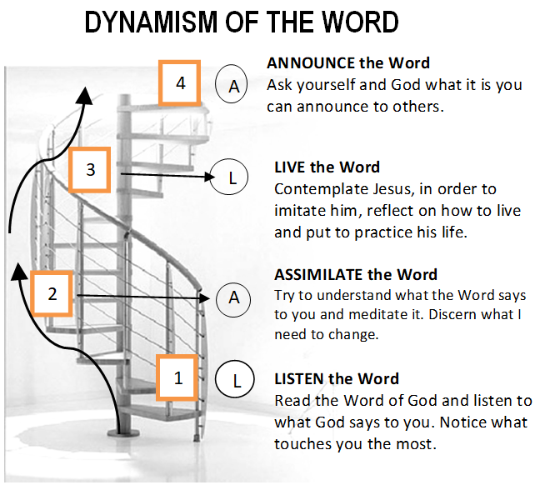

Guidelines for Prayer
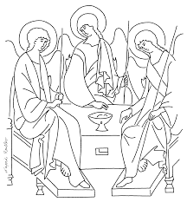
“Streams of life-giving water will pour out from his heart”
(Jn.7:39)

May 28-June 3, 2018

Enlarge the space of your tent for the Verbum Dei Spirituality

General Objective:
- to discover the generous love of God in our daily life as one experience it being in contact with this love in the Eucharist

Objective of the week:
To recognize the Eucharist as a spiritual source of our life

